DELTA

The New Employee Management System

Team 53

**Introduction** **1**

**Timescale of work** **2**

**Our set of deliverable contents** **4**

**Functional and Technical Specifications** **18**

**Defined scope for the project** **29**

**Requirements elicitation** **29**

**Challenges of working within your chosen domain** **30**

**Analysis of existing players in the market** **32**

**Our Approach: User-Centred Design (UCD)** **36**

**Early prototypes; strengths and weaknesses** **37**

**Validation of design** **43**

**Critical evaluation of our concept:** **46**

# 

# 

# Introduction

Employees are an important asset to any organisation - happy and productive employees are therefore important in bringing success to an organisation. An EMS (Employee Management System) has the capability to provide employees encouragement, stimulus and make them feel they are part of the company. Not only do they improve real time communication, they also improve efficiency in employee-related tasks. With an EMS that can be accessed easily from one’s mobile phone, employees can access the functionalities of the EMS anytime, such as applying leave on the go, see scheduled meetings, messages and upcoming courses that they need to attend. Therefore we have decided to go ahead with an employee management system to cover the daily needs of employees and HR managers.

**This employee management system we are proposing is called DELTA - we will use this name throughout the report to describe our EMS software**

# Timescale of work

Our team has gathered to discuss and assign roles to each one of us so that our workload can be shared and each member can play a part in finalising the prototype. We made use of a gantt chart to assign working duration and also plan the timing such that we can finish the prototype by the end of the submission.

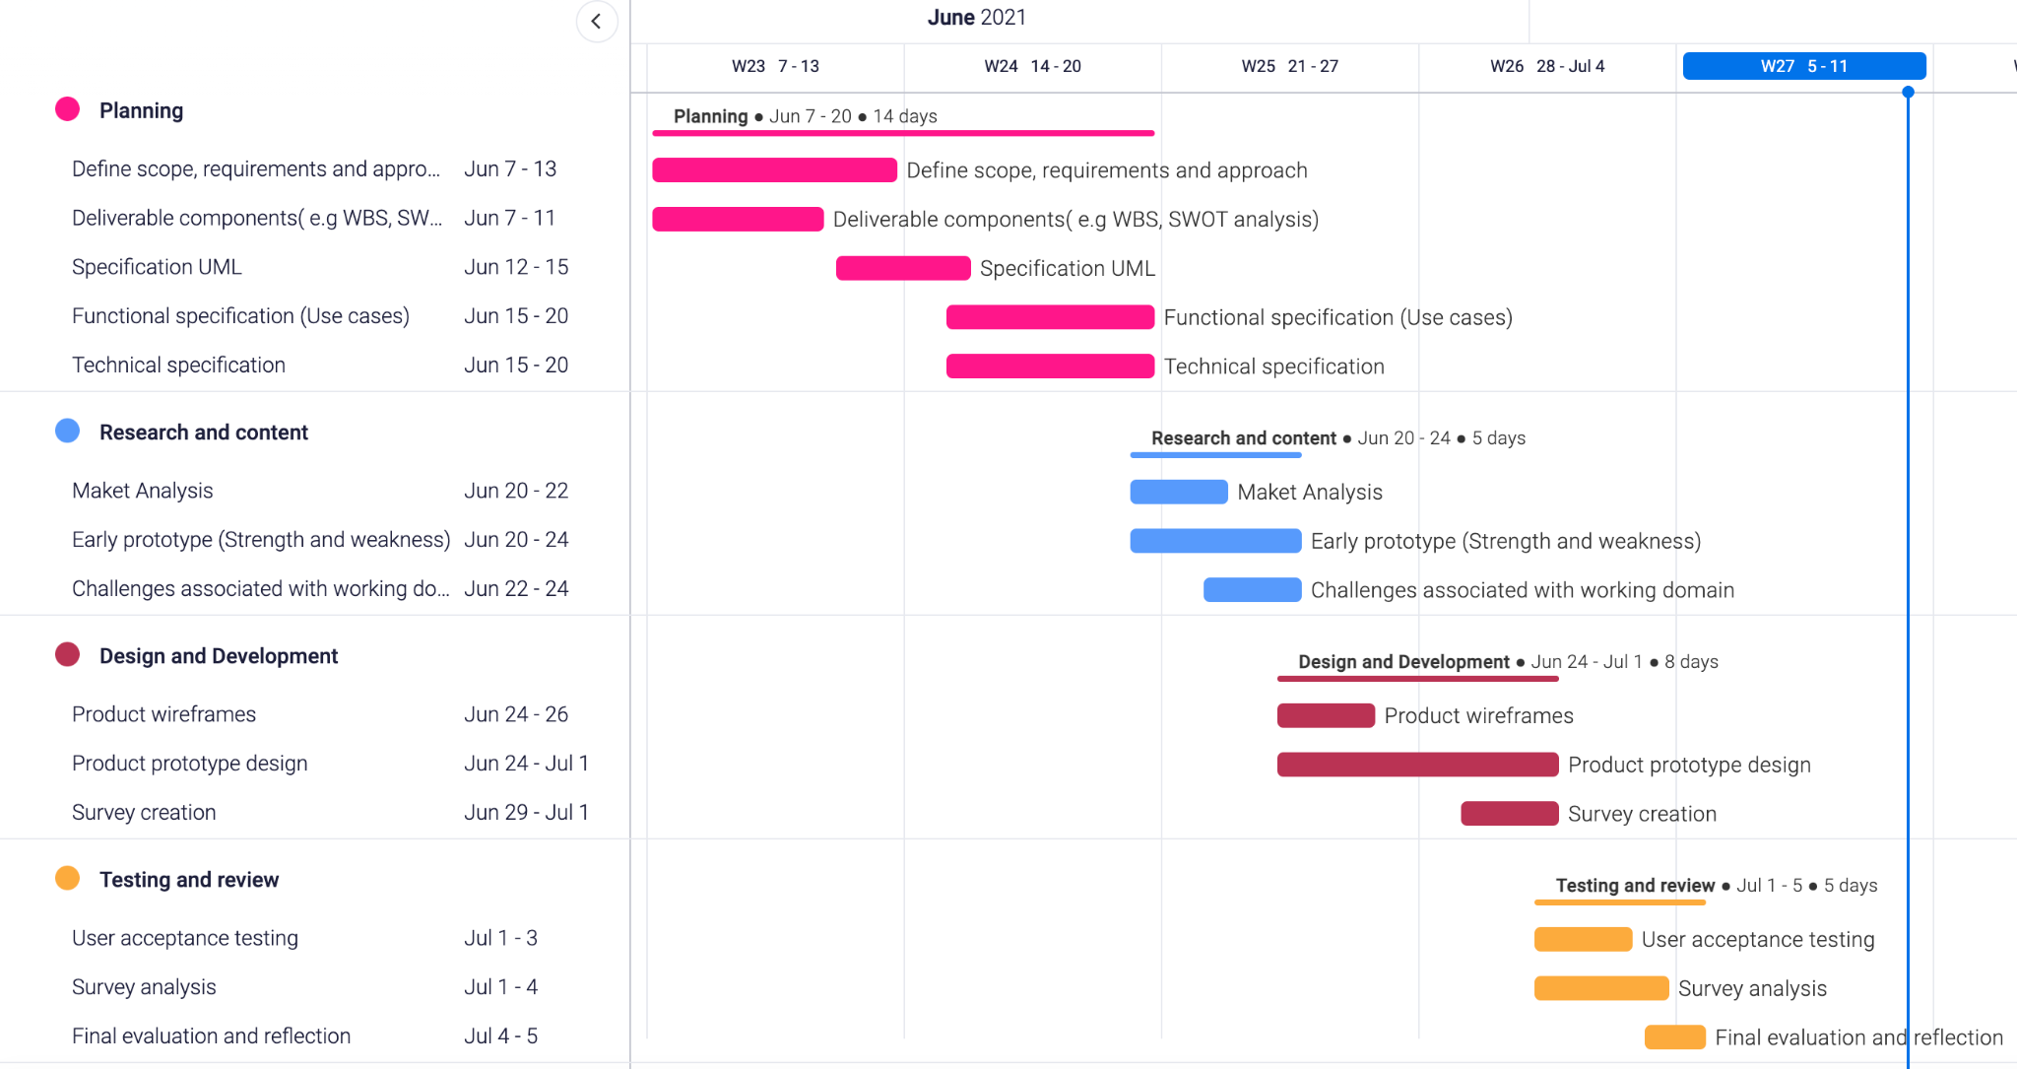

Roles assignment can be seen in the image below:

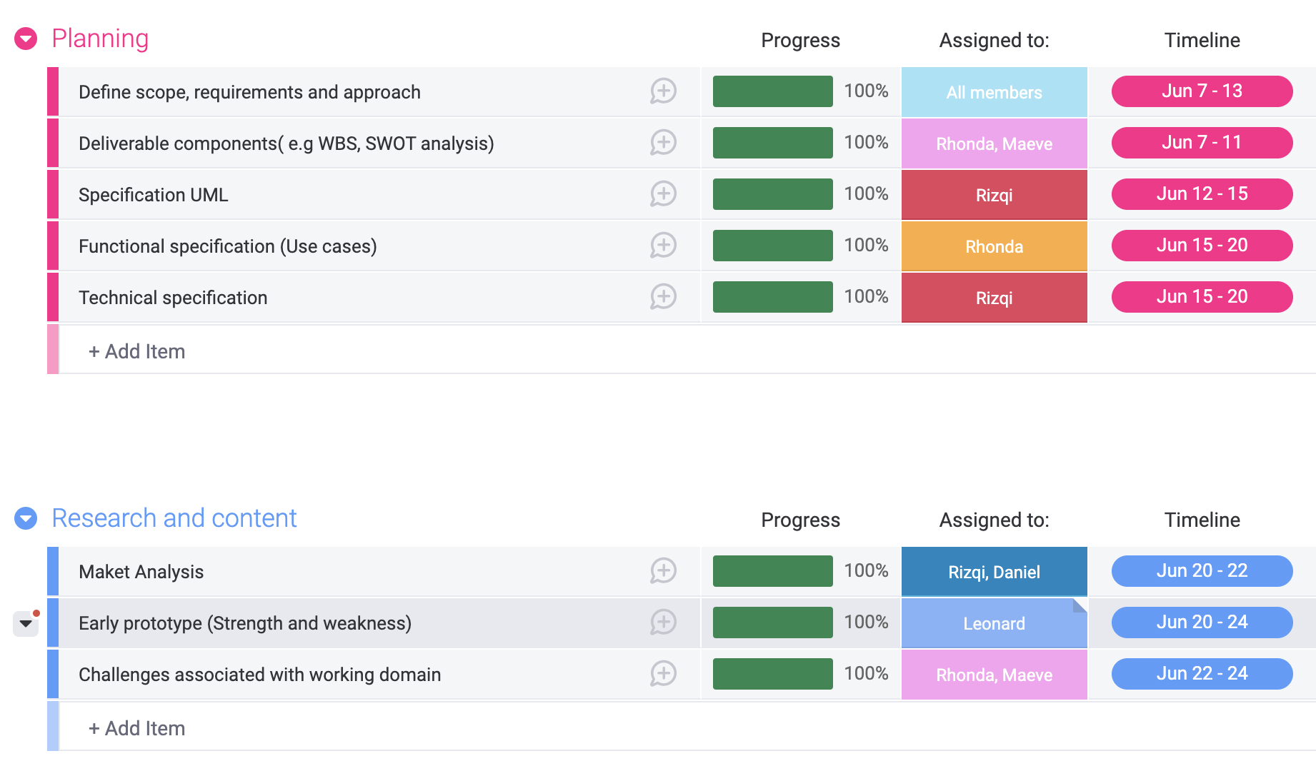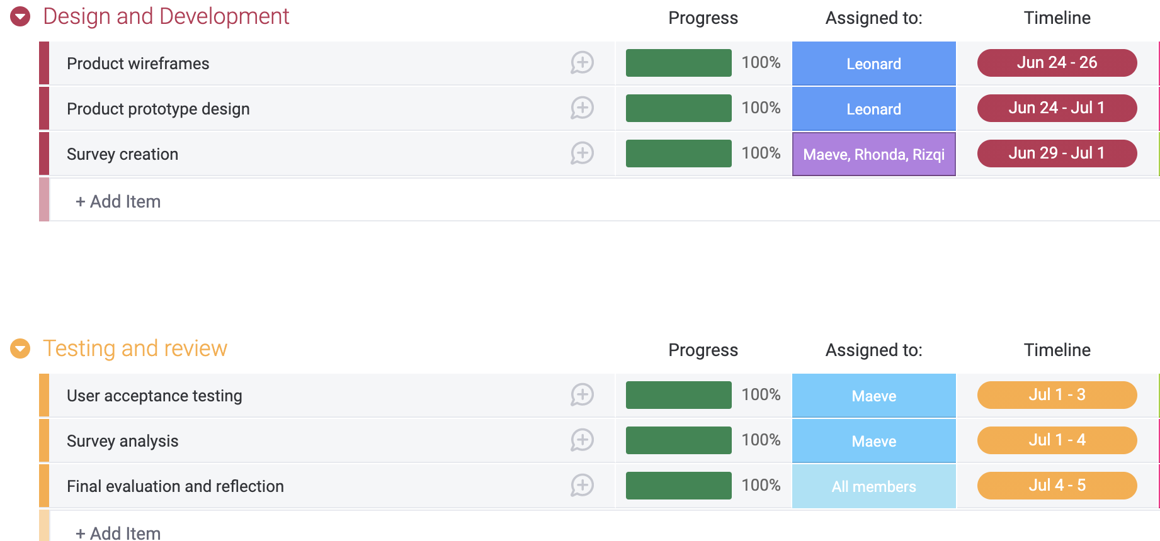

# 

# 

# Our set of deliverable contents

**Work breakdown structure**

Our team designed the WBS shown below so as to singlehandedly integrate the scope of our project and to ensure the project plans are in alignment. We broke down our work into 5 stages - planning, getting requirements, software designing, tracking and lastly testing.

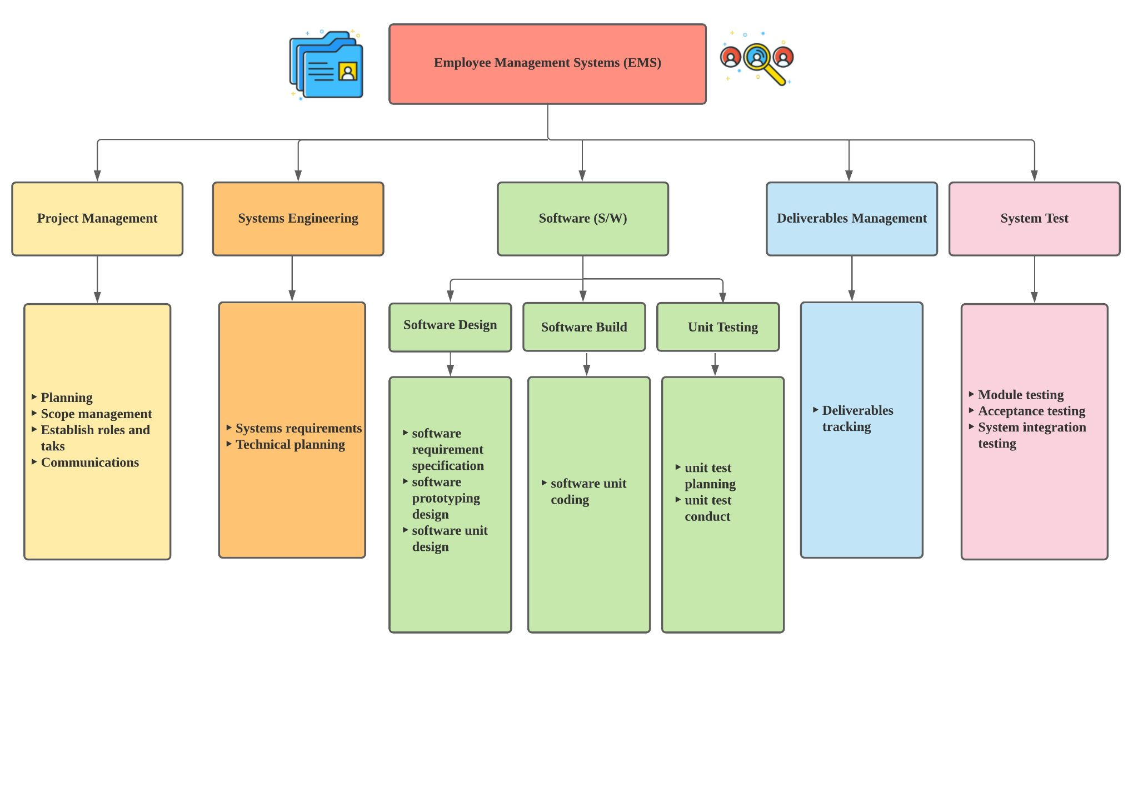

**SWOT analysis**

The fundamental goal of a SWOT analysis is to assist us to understand all of the elements that go into making a business decision. It is essential to carry out a SWOT analysis before committing further.

With this SWOT analysis, our team can better understand the pros and cons of our proposed system and understand where our strengths and weaknesses lie. This will also help us to see what opportunities are available for us to help market and promote our product in the future.

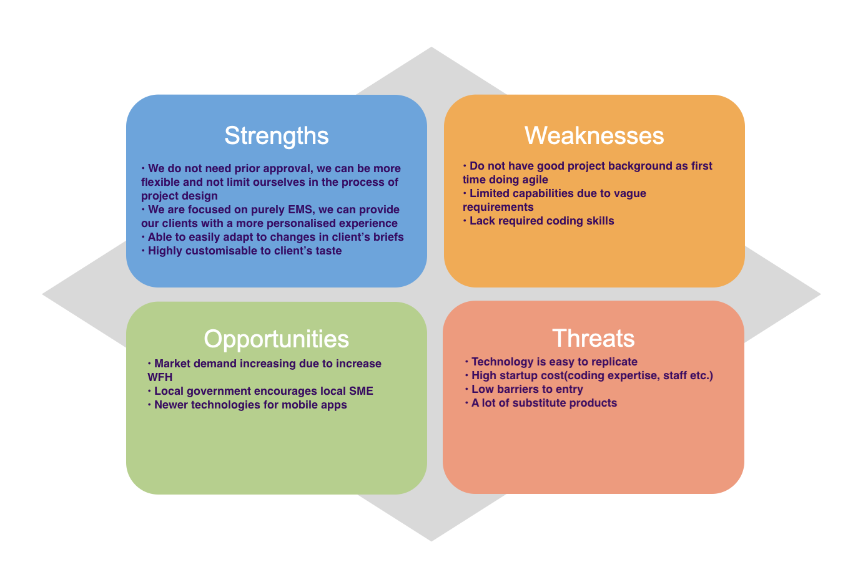

**Mobile App wireframe (Low-Fidelity Wireframe: Employees)**

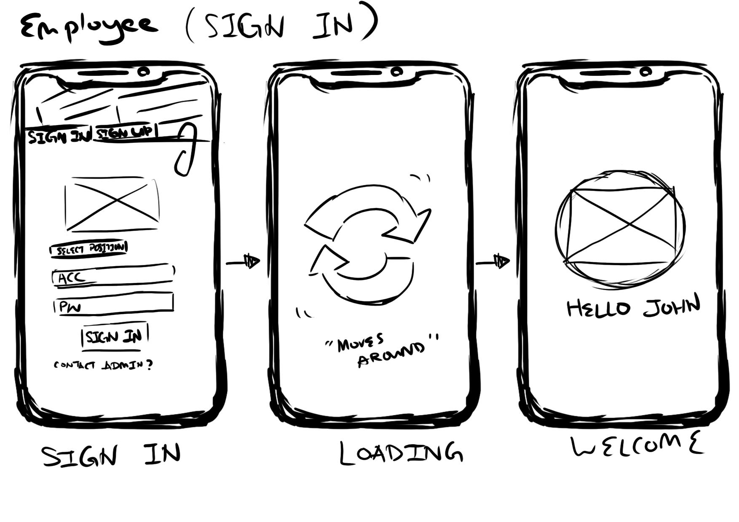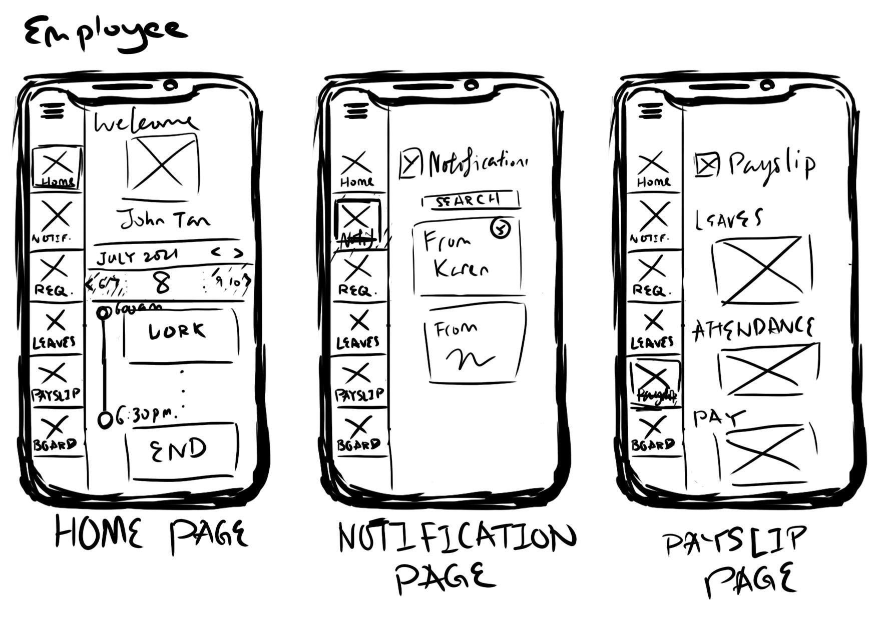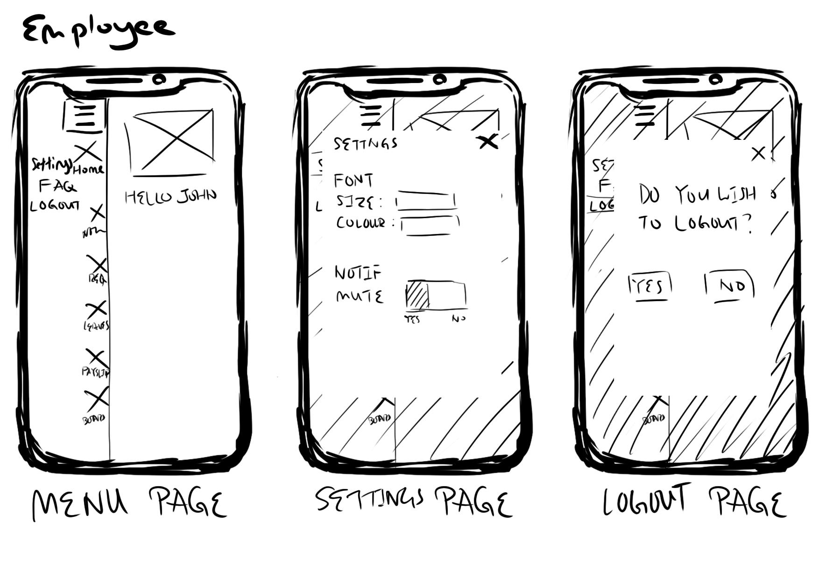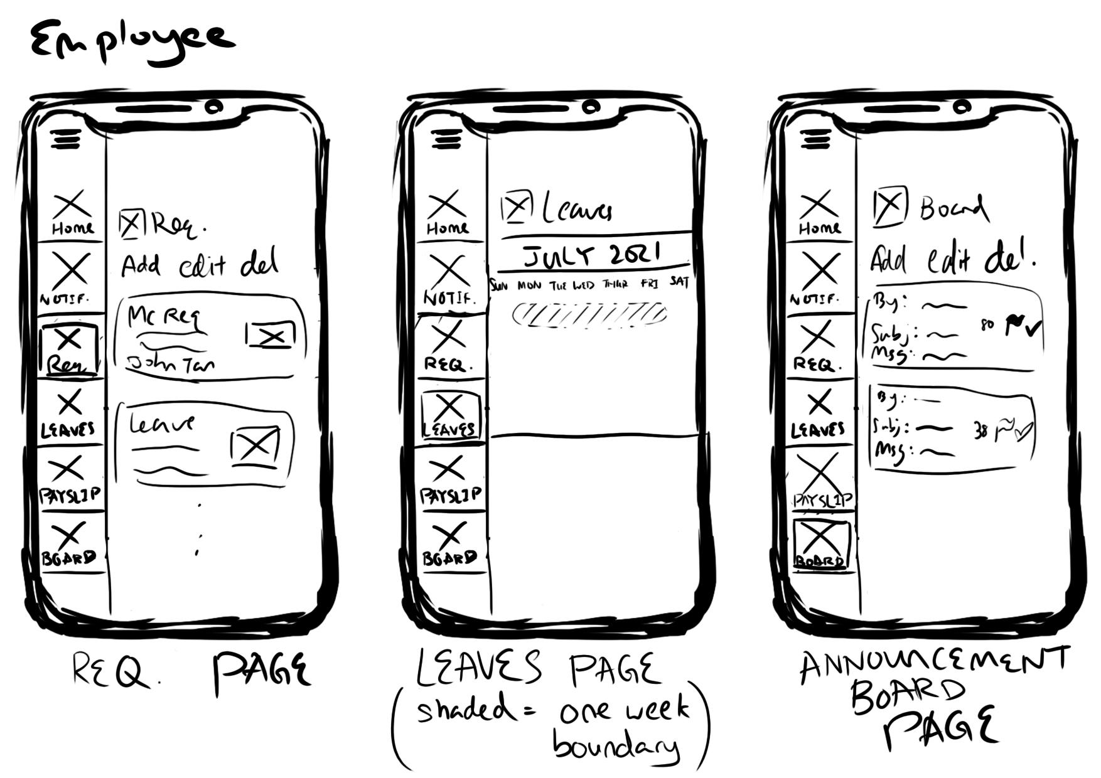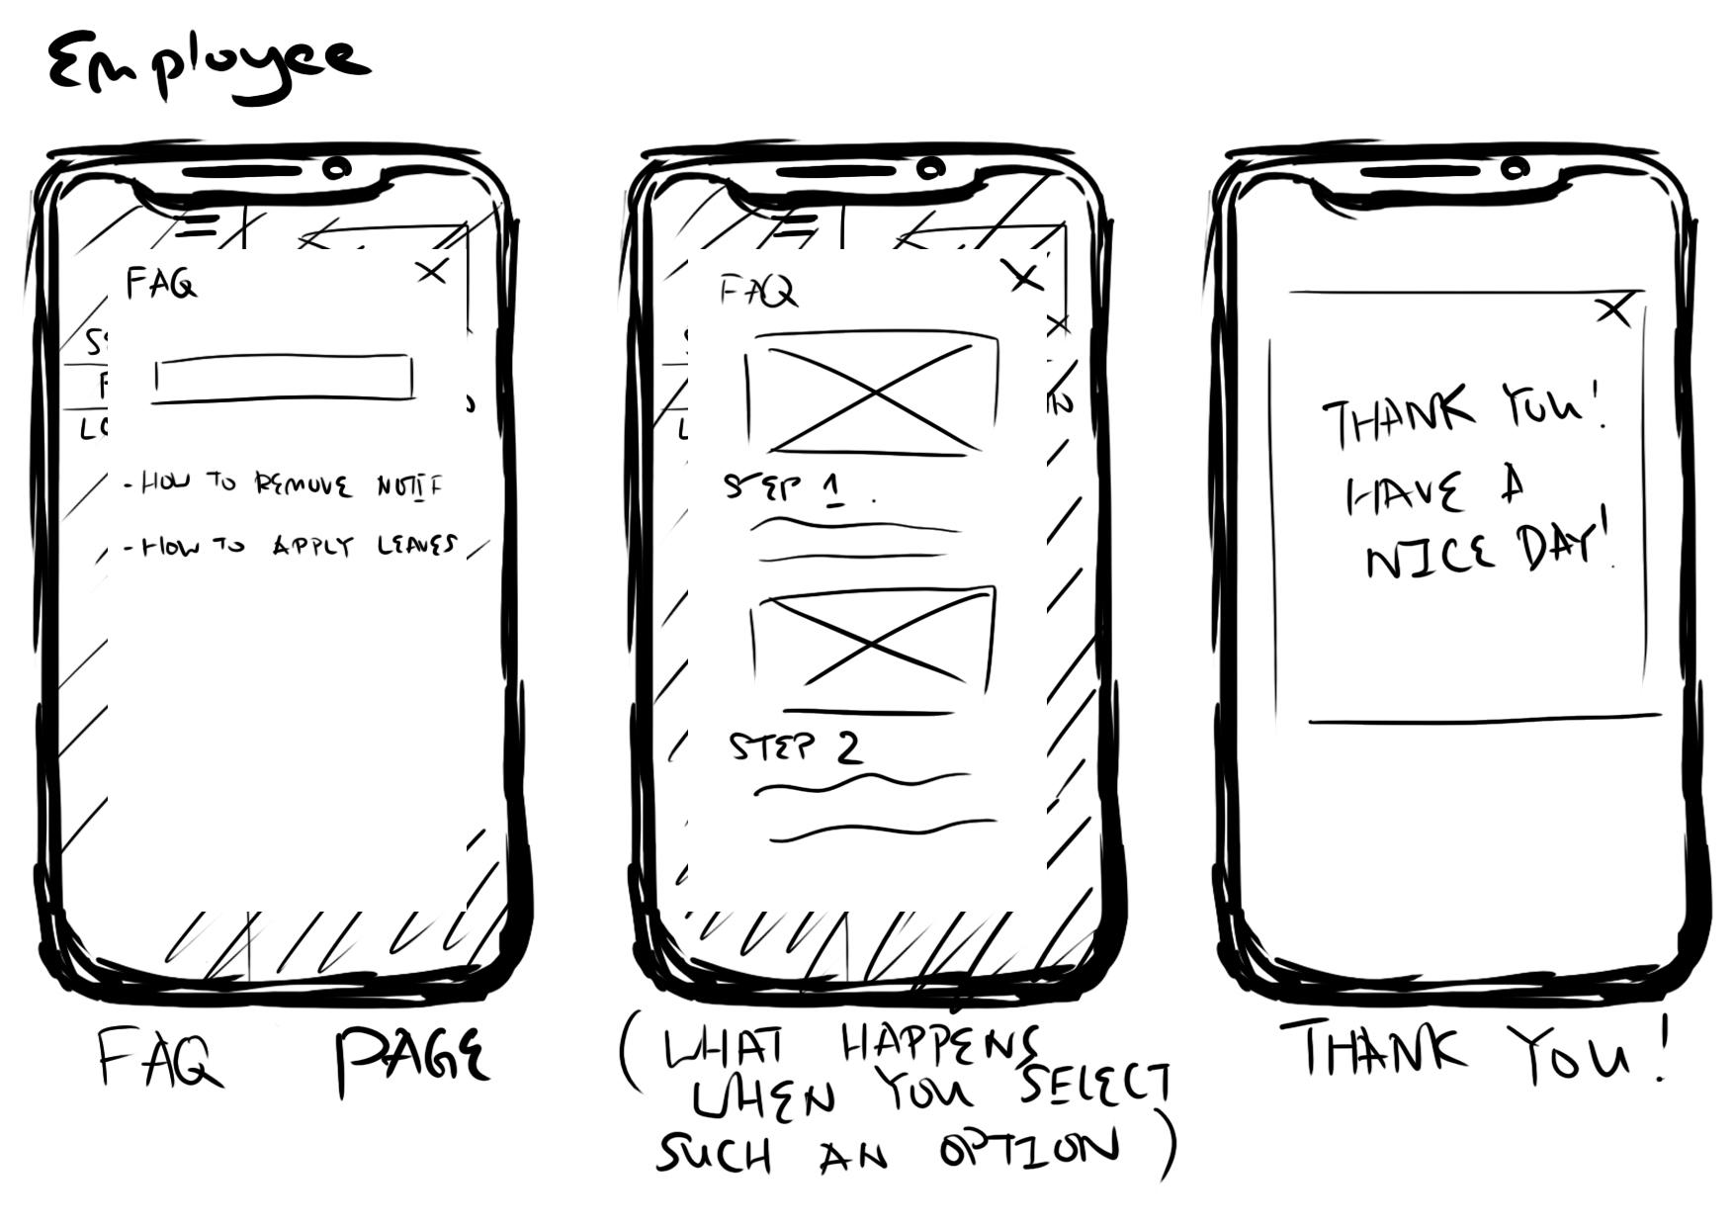

**Mobile App wireframe (Low-Fidelity Wireframe: HR Manager)**

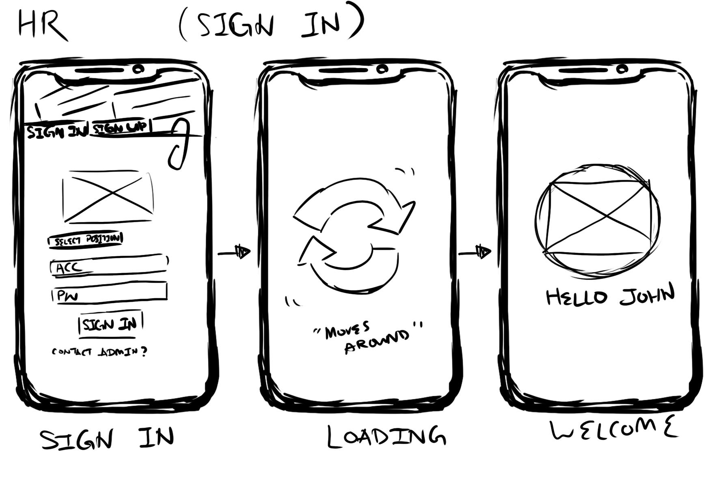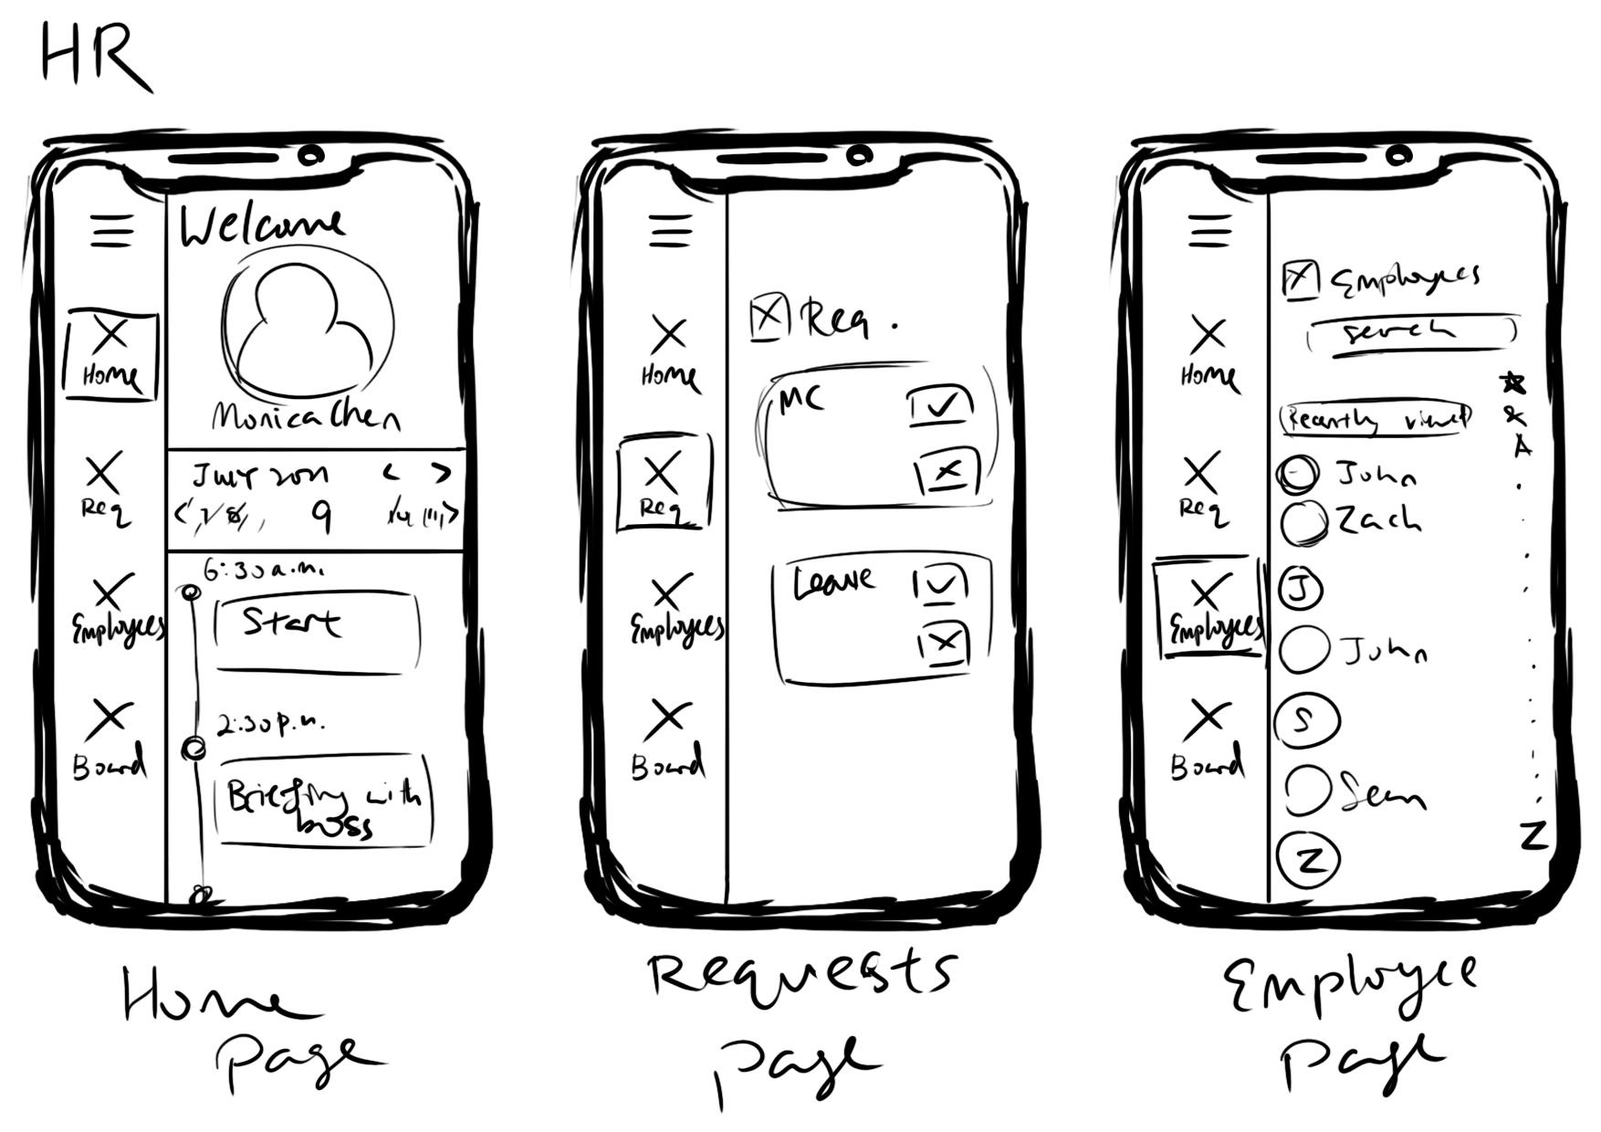

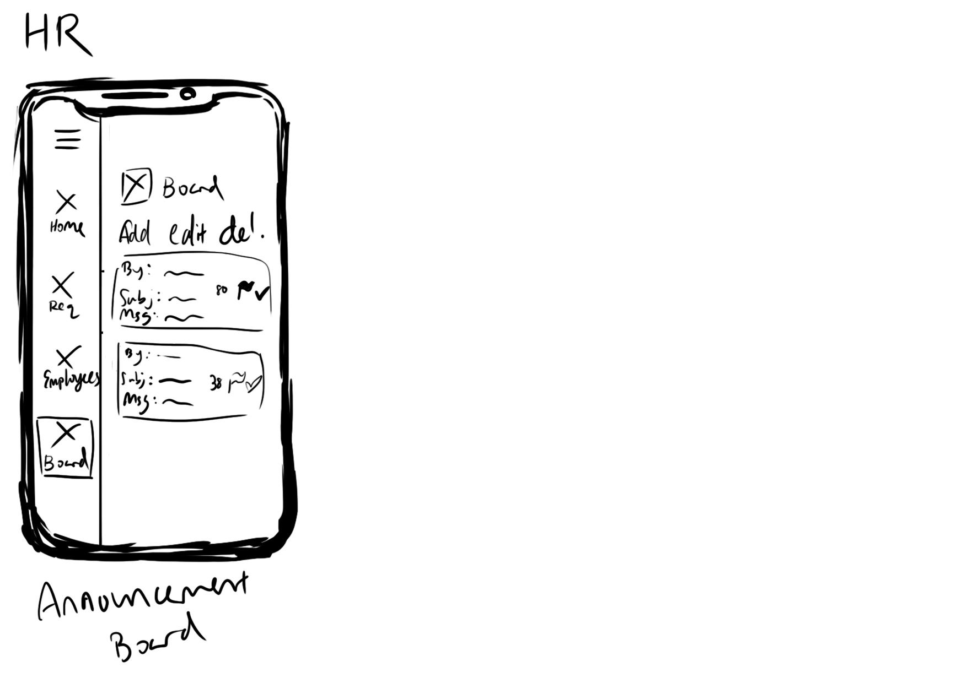

**Mobile App wireframe (High-Fidelity Wireframe: Employees)**

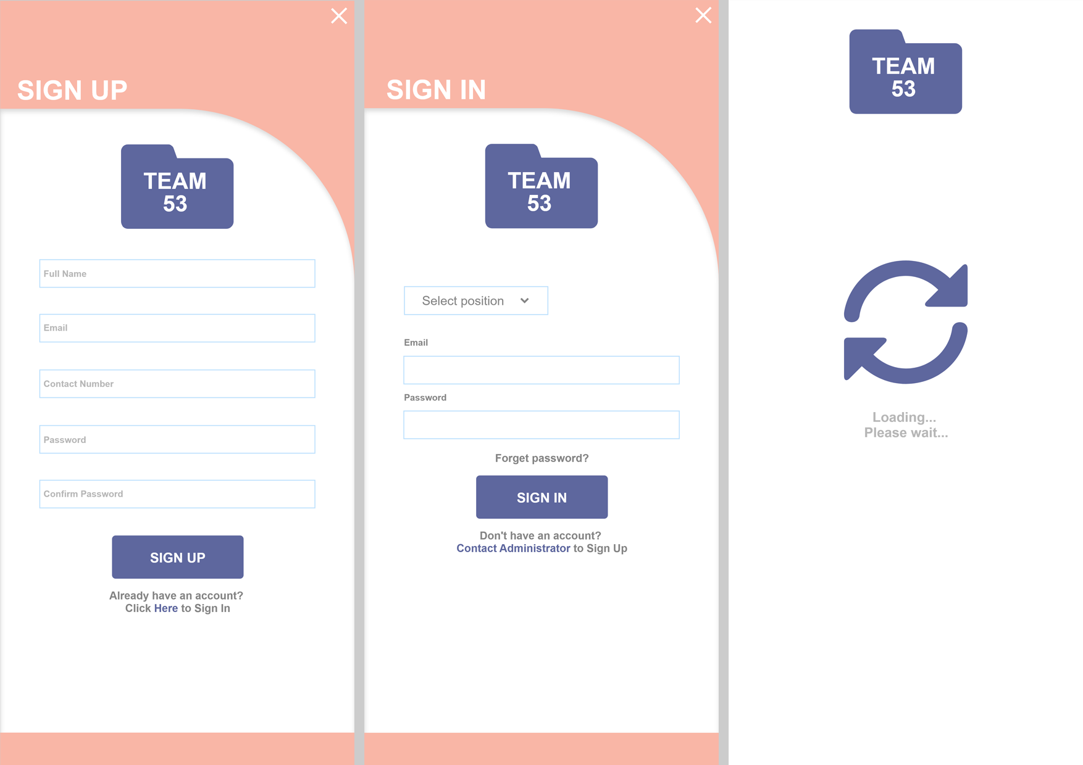

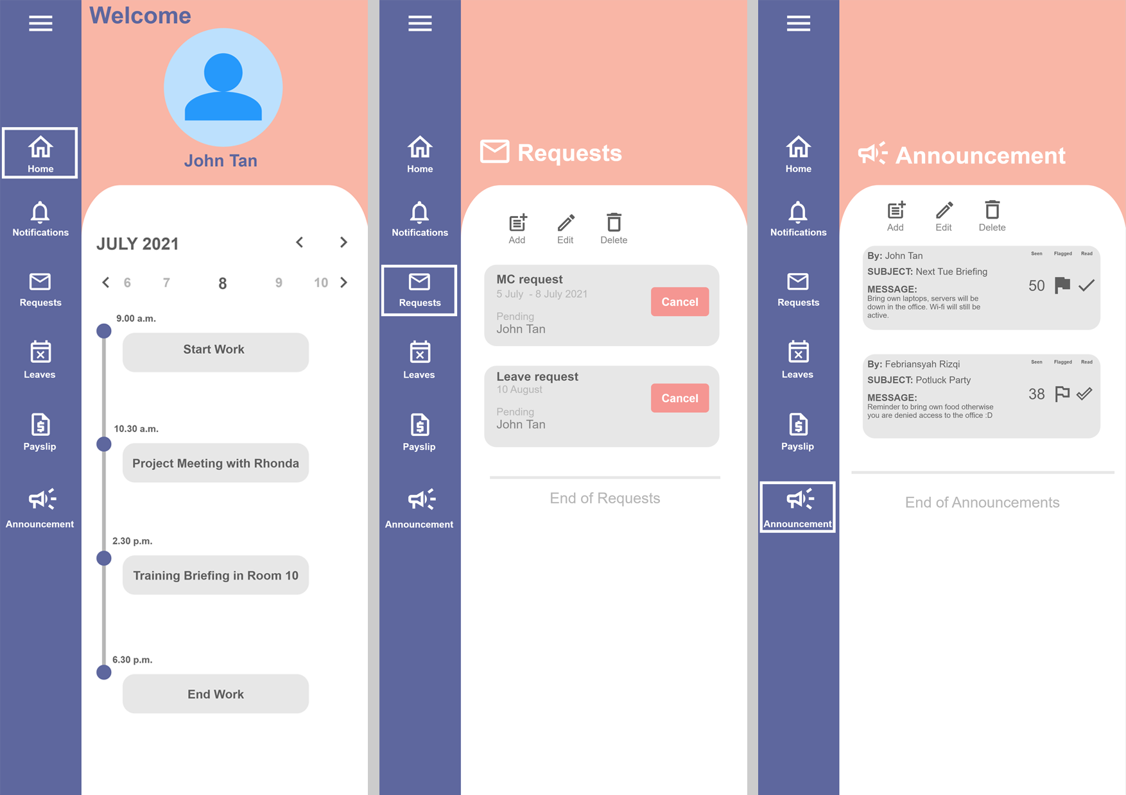

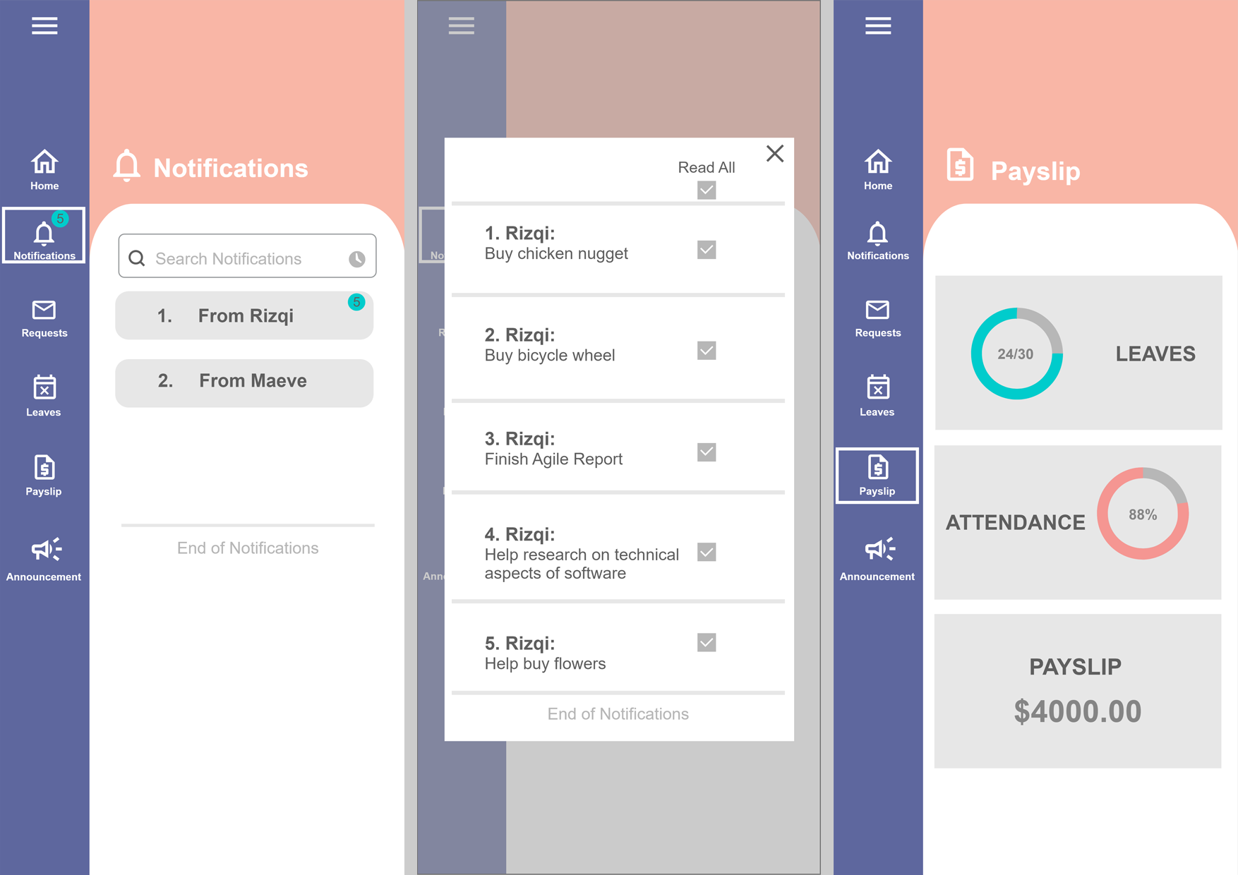

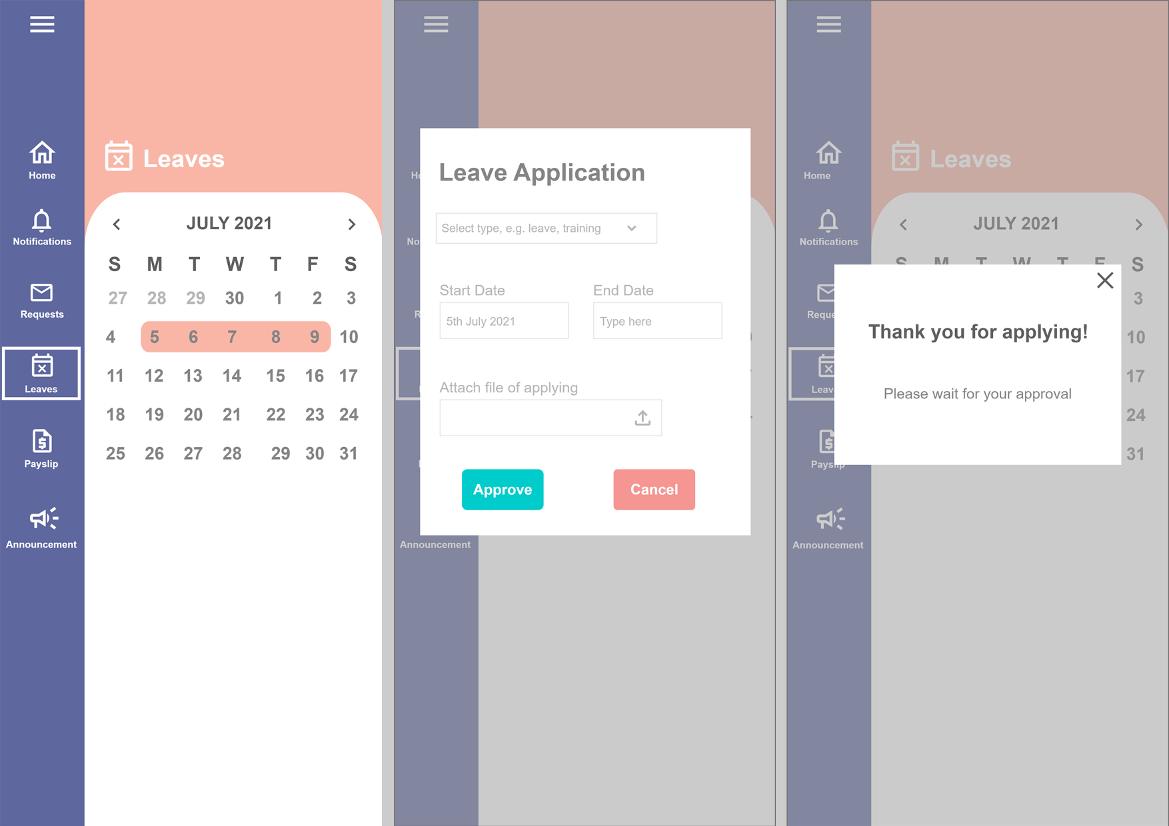

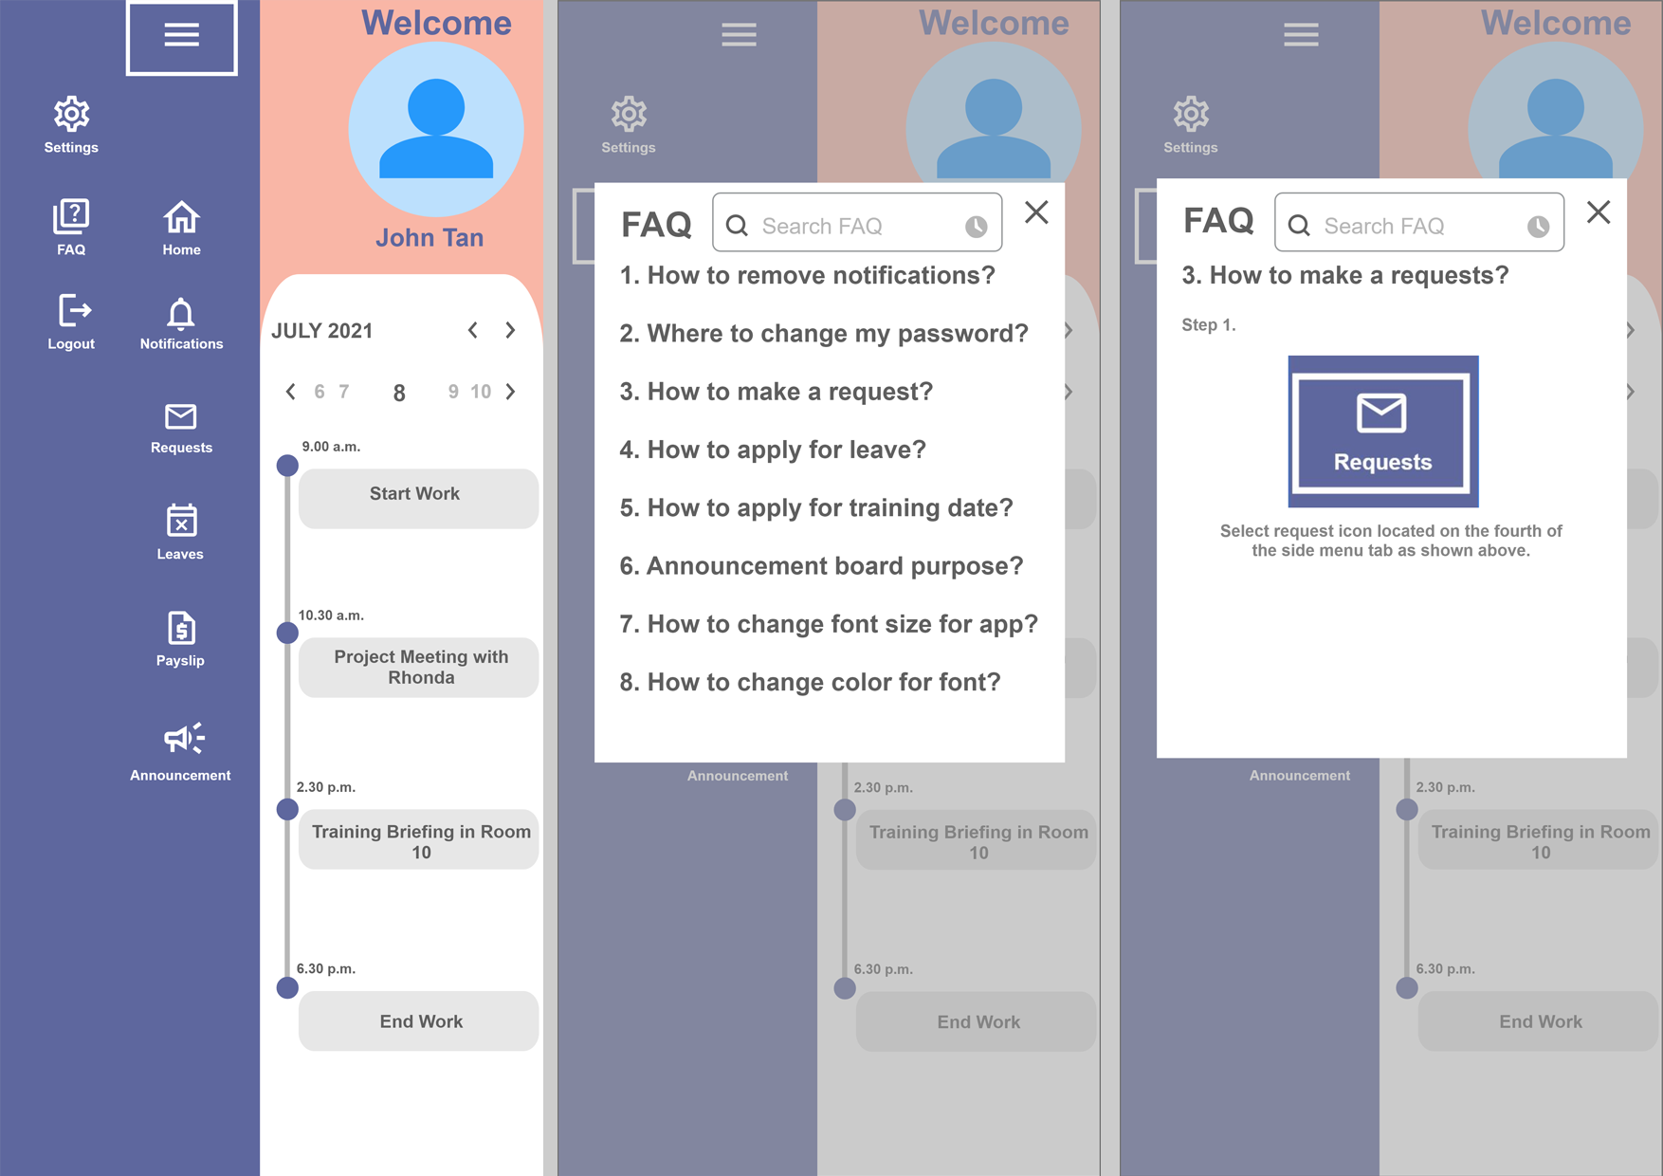

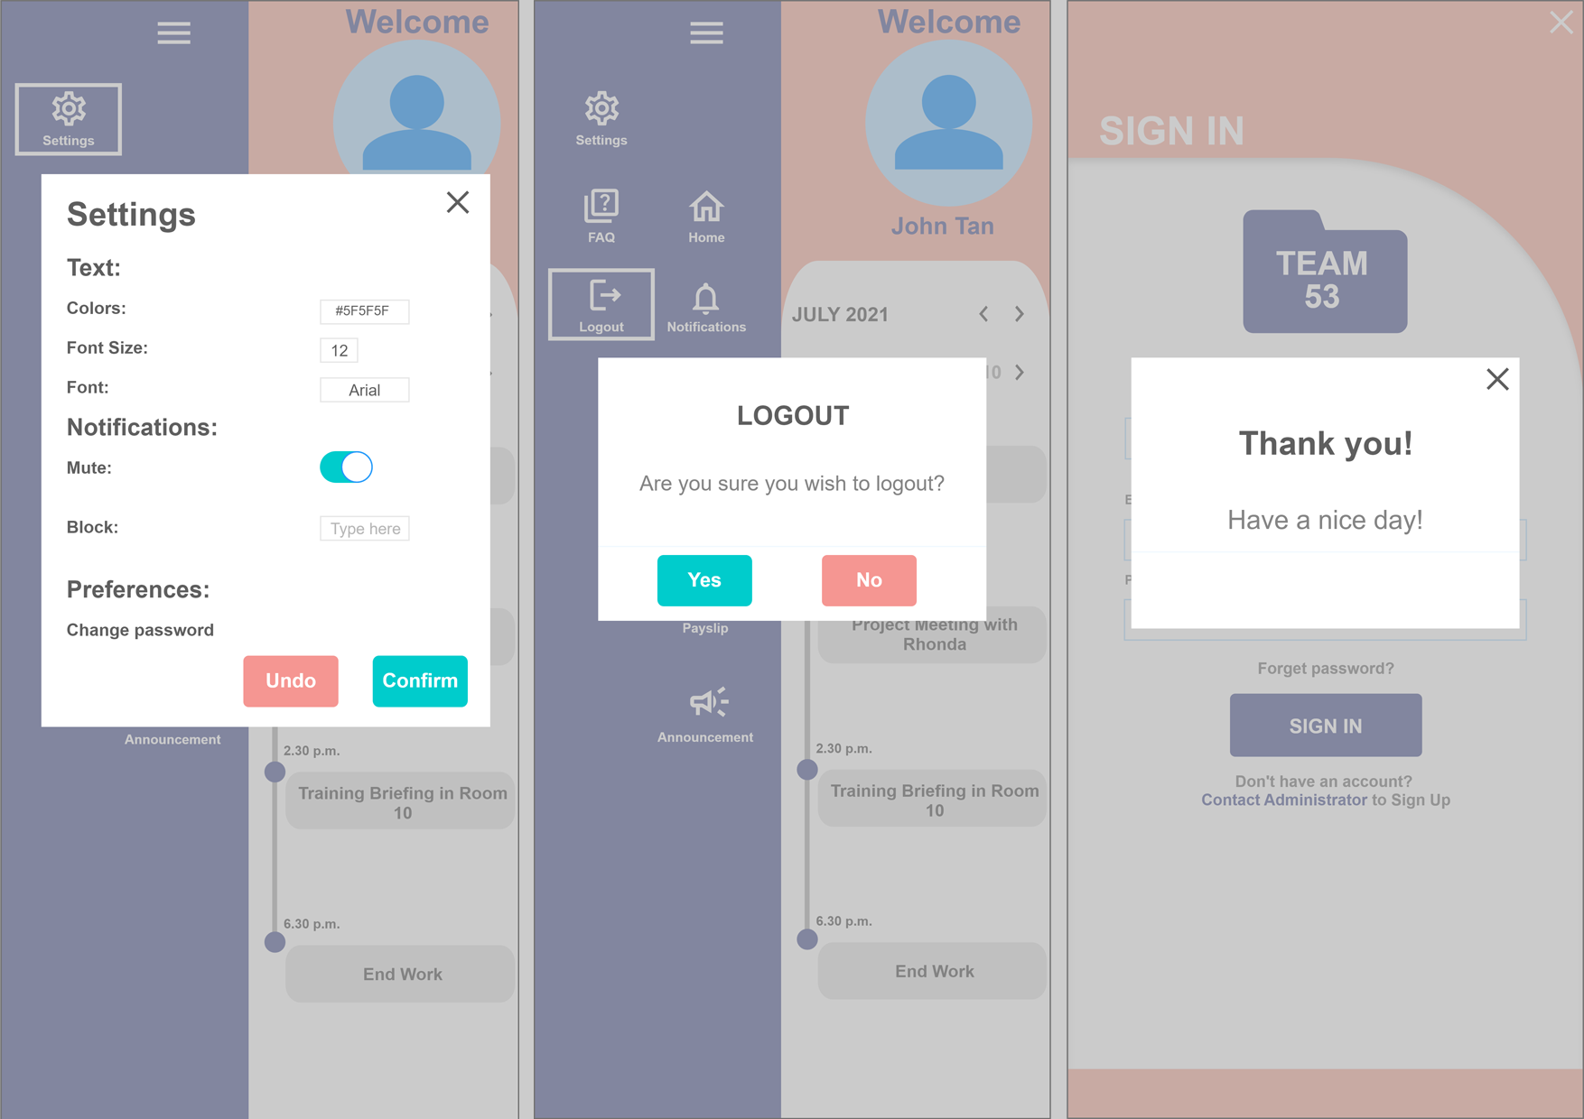

**Mobile App wireframe (High-Fidelity Wireframe: HR Manager)**



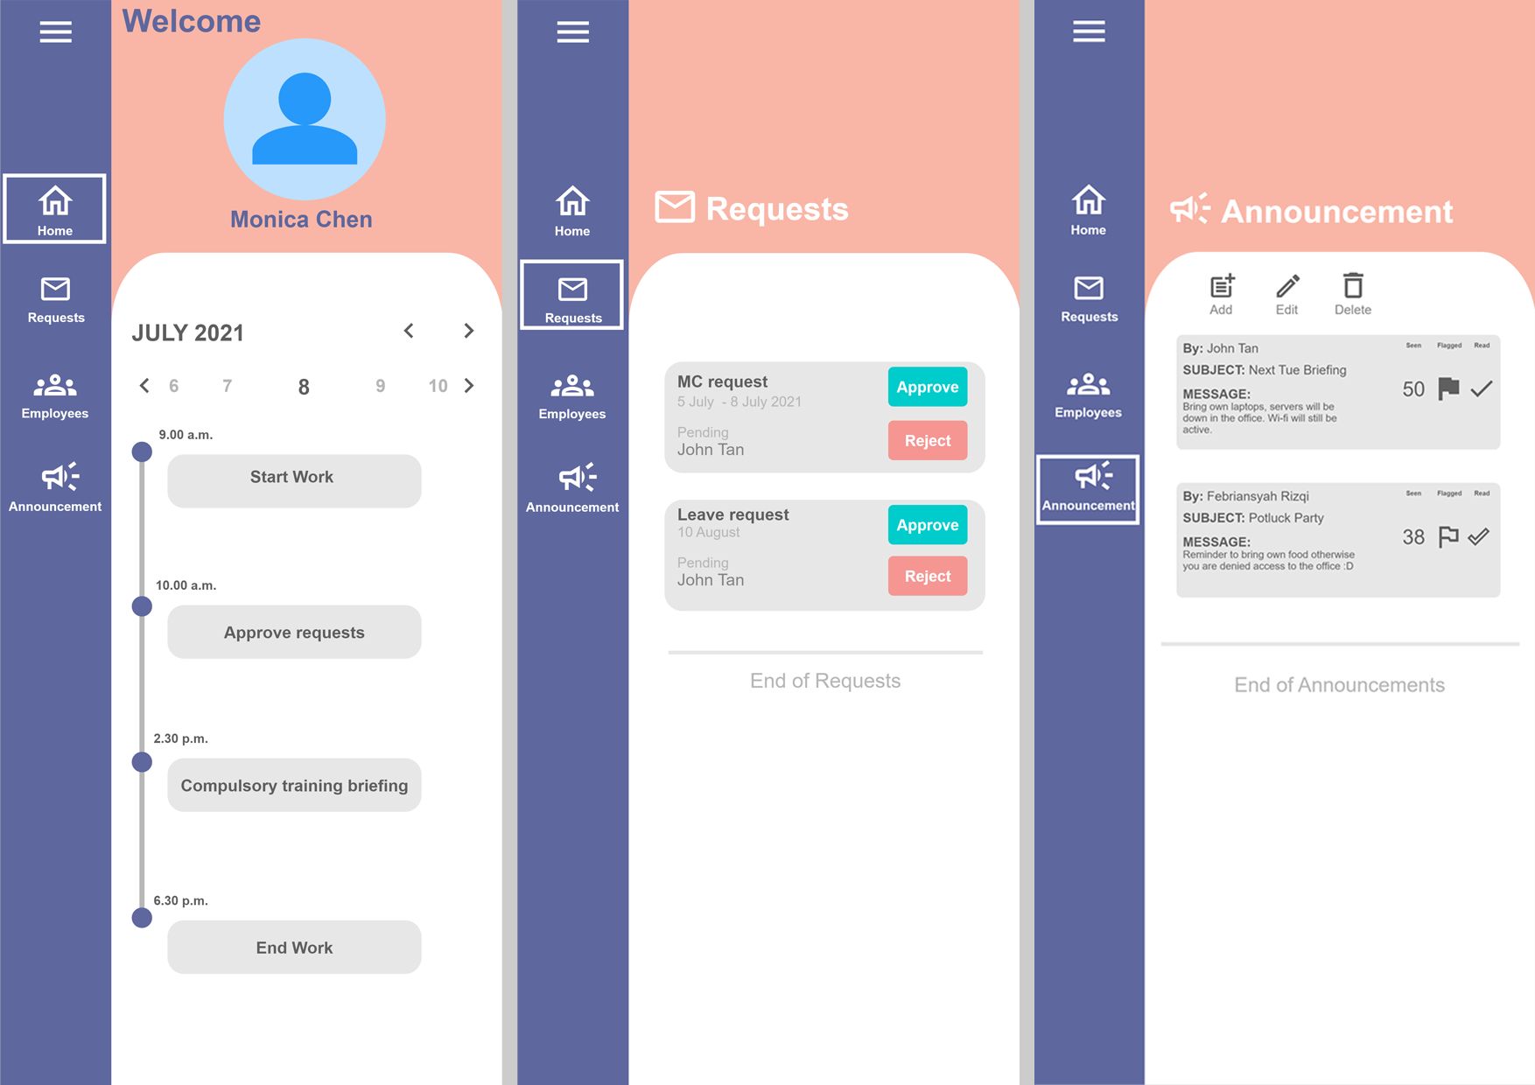

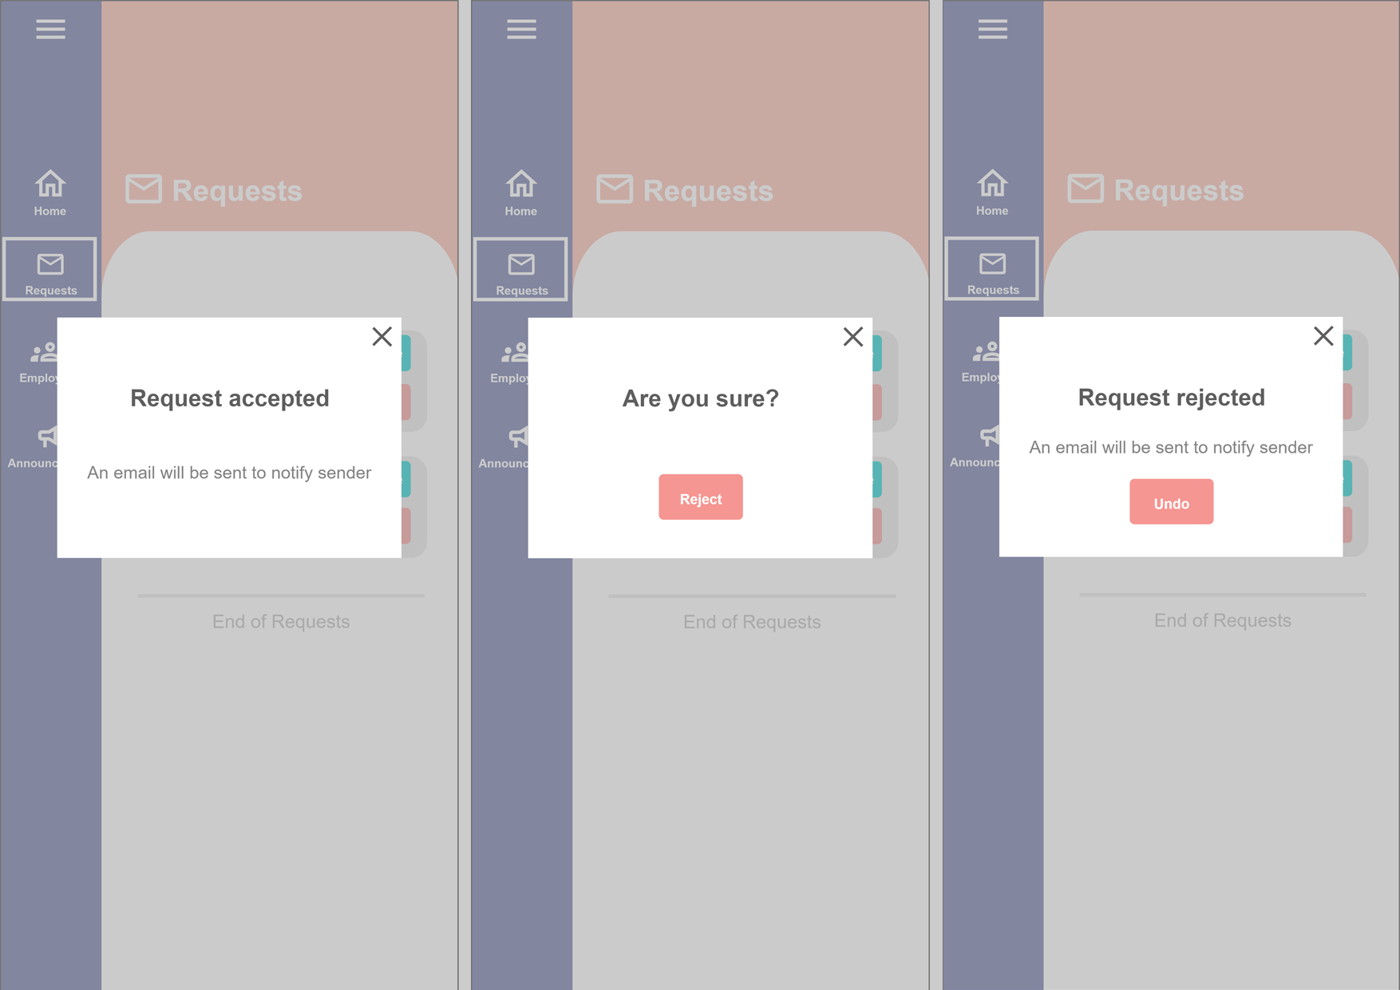

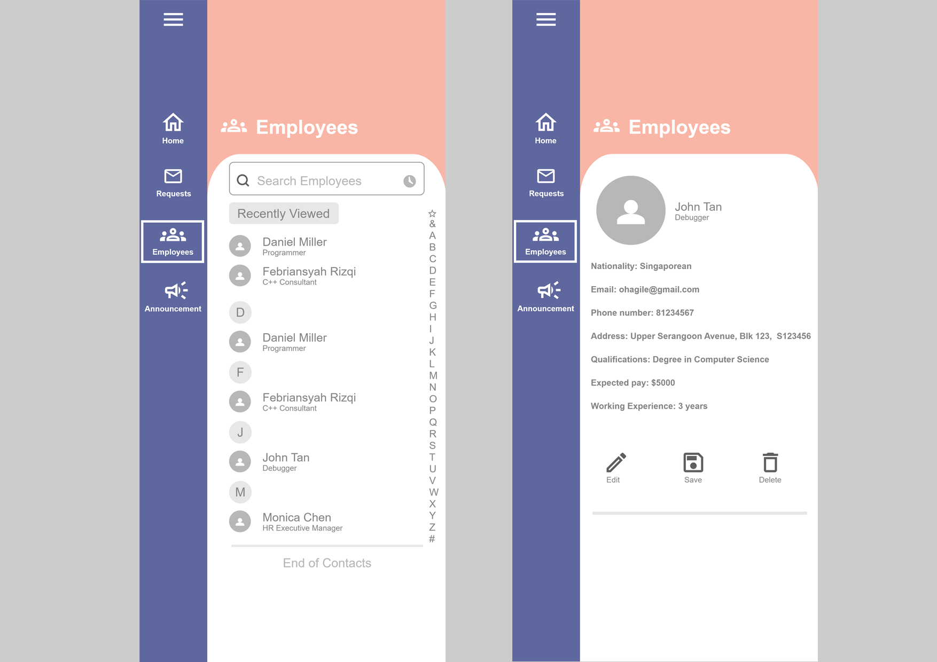

**UML Diagram**

This diagram also helps us to visualise all the functions that we plan to have in our application. There are 2 main user components- employer(HR) and employee. The functions linked to both components are what the respective users can access to.

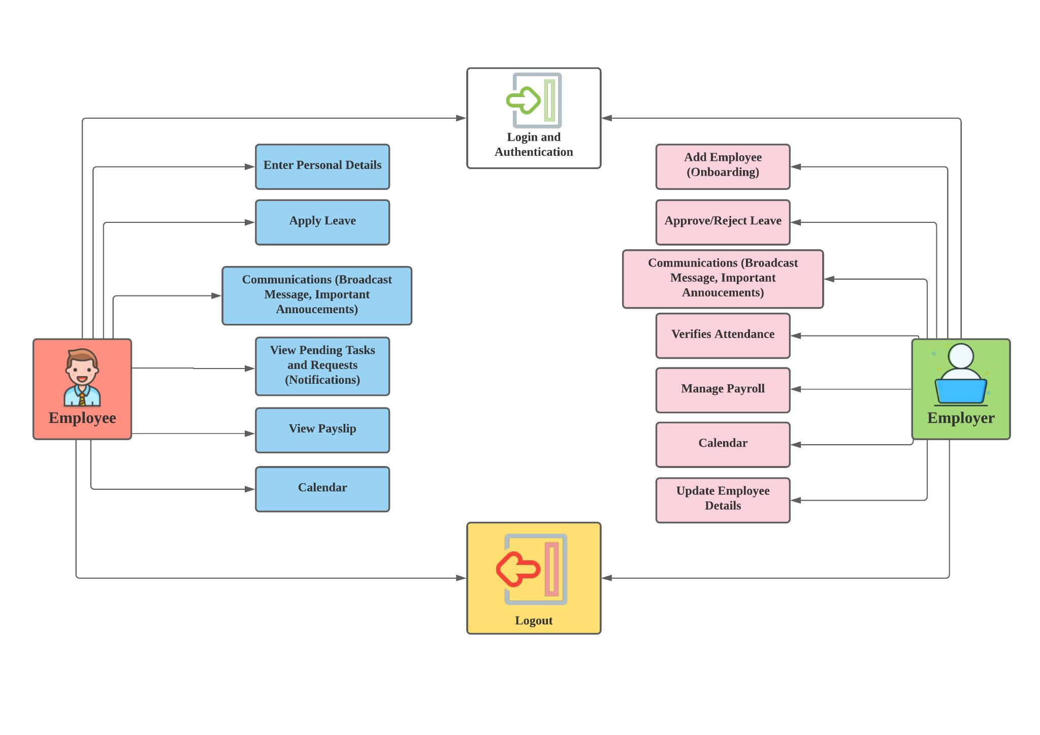

**Class Diagrams**

Below shows the class diagram for employees. This shows the overall functions and classes for each respective component.

**Figure 1 - Employee** 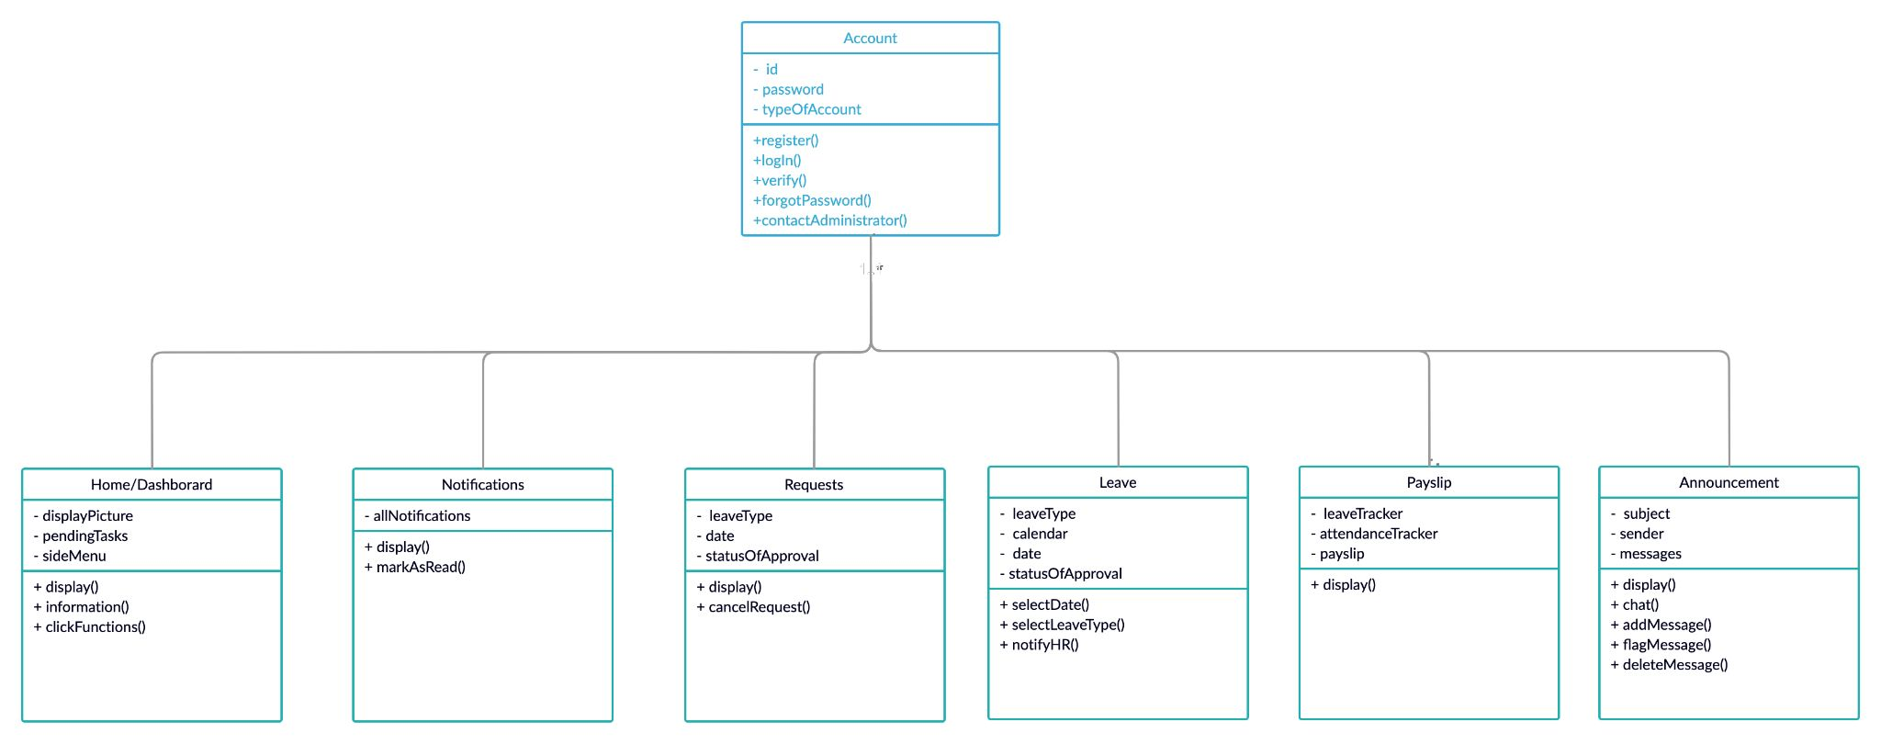

Below shows the class diagram for HR. This shows the overall functions and classes for each respective component.

**Figure 2 - HR**

# 

# 

# Functional and Technical Specifications

**Applicable to all pages are the following:**

**Employee side menu* -**

Settings, Home, Logout, Notifications, View Requests, View Payslip, Noticeboard, FAQ page

**HR side menu -**

Settings, Home, Logout, Notifications, Approve Requests, Approve Payslip, Employee Database, Noticeboard, FAQ page

**USE CASES (Employees) *user refers to employee here**

|  |  |
| --- | --- |
| Login to system | Login page has two input fields: name, password  Login button  Contact Administrator button (For password-related issues)  A popup message with HR details (email & contact-related information) if the user clicks on the Contact Administrator button)  *Action*:  User can login into the system, if they forget their password they can click on the ‘Contact Administrator’ button |
| Home/Dashboard | When the user first logs in, they will see this page.  Top half shows:   * Display picture (of employee), date   Bottom half shows:   * Details of pending tasks in condensed form   *Action:*  User can click on any of the functions of the side menu*  User can return to the home page with home button |
| Notifications page | The screen displays all kinds of notifications   * initially condensed notifications will be displayed here   Mark as read button  *Action:*  Users can view all notifications here and mark the notifications as read. Notifications that have not been marked as read will be highlighted |
| View Requests page | The screen shows all pending types of requests of the user  Each request shows:   * Type (medical leave, off-day, childcare leave etc.) * Date * Status of approval (Pending/Approved/Rejected) * Cancel button   A pop up message to confirm the cancellation of a request  *Action:*  The user can view all pending requests and their details. They can also click on the cancel button to cancel the request |
| Leave Page | The screen shows a clickable calendar  *Action:*  Employees can click on the dates of a calendar to request for a leave.  After selecting the date, the employee will be prompted to select the type of leave he is requesting for - e.g. MC  The HR team will then be notified (a notification on the leave icon in their dashboard) |
| Payslip page | Screen shows:   * Leave tracker * Attendance tracker * Payslip attached   *Action*:  The user can view the number of leaves he has left and his attendance performance |
| Broadcast message/ announcement page | Screen shows the :   * Subject * Sender * Messages * Number of users who read and acknowledged the announcement * Flagged important message   Display number of items option  Add/Edit/Delete message button  Flag as important message button  *Action*:  Employees/HR can add a new message to broadcast it to the rest of the organization. They can flag it as important too. |

**USE CASES (HR managers)**

|  |  |
| --- | --- |
| Login to system | Login page has two input fields: name and password  Button login.  Action:  User can login into the system, if they forget their password they can click on the ‘Contact Administrator’ button |
| Home page/Dashboard | When HR manager creates/deletes or updates the user list:  Top half shows:   * Display picture, date   Bottom half shows:   * Tasks to be done as shown on the side menu |
| Add/Edit/Delete/List employees page | New user section  Mandatory fields:   * First, last, middle name * Nationality * Email * Phone number * Address * Qualifications * Expected pay   Optional fields:   * Working experience   Save record button  Edit record button:  Delete record button  Search Employee list  Action:  Admin must fill out all mandatory fields before the save button can be activated.  After saving, the results will be added to the list of users screen  When admin clicks on the delete/edit record button there will be a popup confirmation with the button choices of yes or no  Can search for employees via search function  If admin clicks on a user, all the fields previously filled up will be displayed on screen |
| Approve request | Screen shows:   * Employee details * Type of request (Medical leave, childcare leave) * Date   Approve/decline button  Action:  Admin can choose to reject or approve the request by clicking on the approve or decline button.  Once the button has been clicked on, the user will be notified, and the details of the HR manager that approved will be given as well. |
| Broadcast message/ announcement page | Screen shows the :   * Subject * Sender * Messages * Number of users who read and acknowledged the announcement * Flagged important message   Display number of items option  Add/Edit/Delete message button  Flag as important message button  Action:  Employees/HR can add a new message to broadcast it to the rest of the organization. They can flag it as important too. |

**Technical Specifications:**

Overview

As technology progresses, mobile phones have been a daily part of our lives. It is of great convenience if users are able to view their management status and their work progress at their fingertips. This process is seamless and intuitive, as we have implemented user-friendliness and simplicity into our application. It gives new options for businesses to reform and improve traditional core HR procedures, making them more functional by increasing productivity and enhancing employees’ satisfaction, resulting in a big stride toward futuristic human resource management.

Goals or Product and Technical Requirements

HR mobile applications can consolidate the most important HR processes, for instance payslips review, vacation leave requests and approvals, time attendance records, benefits, work reminders and schedules, and organisational information, into a single, easily accessible location.

1. Databases of employees are now more accessible than ever before

Employee data may be accessed quickly and easily with the help of a mobile app. Every single employee record is available to the employers at any time. Moreover, employees and supervisors may use the mobile application to request and authorise time off, check leave balances, view payslip and produce reports.

1. A more effective communication internally

Employees can receive notifications and reminders on their smartphones, such as forthcoming or overdue tasks, pending applications, or crucial communications from the board. With a mobile app, HR managers may contact their staff at any time and from any location. Employers may keep them up to date on what's going on, reach out to them using the chat features in the mobile HR software, and get them to communicate if there are any difficulties. In general, mobile applications allow us to communicate at any time, and employers won't have to wait for their employees to log in to their computer or laptop to connect with one another. Whether the employees are on the road or at work, our HR mobile app will allow employers to send messages to them.

1. Leave Application

On the dashboard, employees may check their current leave balances, request leaves, and access their previous leave history, while managers can review and approve leave requests. There is no need to worry about missing work and getting sick when employees can ask for leave from home with the click of a button on their phones.

Future Goals

Below are the functions that we wish to implement in the future.

1. Performance Booster

Mobile applications allow employees to measure their progress toward their goals and provide regular and permanent feedback. We provide the option of rewarding a colleague for outstanding collaboration through a badge entitlement or vote rating. We provide the option of rewarding a colleague for outstanding collaboration through a vote rating or badge entitlement. Employees can express each other gratitude, appreciation and recognition for their hard work and positively affect each other's performance results in this manner, which quickly straightens out the team work at no expense.

1. Walk and Learn on the Move

Mobile learning is the most rapidly growing field of HR technology. We will replace traditional training courses with tools that allow employees to learn in a more acceptable and far easier way, whenever and whenever they have spare time. Everything is stored on the cloud, including videos, games, quizzes, and tutorials, with the goal of delivering continuous knowledge, upgrading and increasing employee engagement on the move. After they have attended and completed an online course, the HR department may use the mobile app to administer quizzes and other examinations, allowing them to obtain their certificate online. As an outcome, training courses become less difficult, allowing the team to focus on their everyday activities.

1. Providing Feedback

We are trying to employ and create mobile software to measure the company’s culture more regularly and effectively. The application will allow users to conduct anonymous and instant surveys. For instance, the extent of freedom employees have, the collaboration between employees, and any other feedback which will provide an assessment regarding the current work culture.

1. Simplified Recruitment Process

If we want future applicants to stay with us and eventually get hired, the recruiting process needs to be simplified. A sophisticated and feature-rich recruiting tool simplifies the recruitment process for both candidates and managers.

Candidates can apply on the move by filling out the mobile form. Possible candidates won't have to fill out all of the information because the forms are simple. Only the information necessary for rapid processing or scanning is requested. The applicant list is given to management after the details are examined and shortlisted based on a pre-defined algorithm. The HR staff can use the data gathered from a research and study of the candidates, to assist top management in deciding whether or not to hire these individuals. The mobile apps will provide a healthy method of conducting recruitments and will make the process easier for both candidates and employers.

1. Attendance Taking on the Go

Workers will be able to clock in and out from any location, with the help of an internet connection using our mobile application. For personnel who work off-site or who travel frequently, clocking in and clocking out will be an excellent solution. This can be done via geo-mapping. The location where the employee's request was submitted will be pinned in the app and will be forwarded to the superior, along with his request for verification reasons. An HR mobile app has become a must-have for major businesses due to real-time cooperation between thousands of employees in different locations.

**Technical specifications**

* Platform (Android Apple OS) to specify version

Android 6.0 and up or Apple iOS 13.0 or later

* Actual hardware specs of the phone for basic requirements

Camera access 8MP, basic network access(Wifi and 3G mobile data connectivity, Bluetooth 4 and higher), minimum RAM 8GM, storage 100MB, minimum screen resolution/ screen size of 5”, Speakers/LED for notifications,

Processor: Snapdragon 835(dual core minimum)

GPU: Qualcomm Adreno 540 GPU

* We are considering the following languages for the app to be developed in:

Swift(iOS), Kotlin, C, C++, GO, Flutter, SQLite, Assembly, Java, JVM(Android), Python, javaScript, Android SDK, Android standard API

**(Connecteam - Collaboration App, 2021)**

**User Acceptance Testing**

A user acceptance test is a specification where software users test the software to ensure that it can handle the required task before the software is rolled out into the market. It is crucial to make sure that all the functions work as it is in case any part has been overlooked either due to miscommunications or coding errors. For now, since the application is not yet finalised, the test status is set to not ready. Once the application is done, if there is any error or any part that does not pass the results expected, it will be noted down in the comments section to be reviewed. Otherwise, the result is complete.

User Acceptance Testing(Employee)

|  |  |  |  |  |  |
| --- | --- | --- | --- | --- | --- |
| No.  &  Test  Status | Test interface | Scope | Expected results | Comments | Results |
| 1.  Not  Ready | Login interface | Scenario:  User select employee tab  User view and click on fields to enter username , password and the login button  User can click on Contact Administrator button (For password-related issues)  Action:   1. Enter username 2. Enter password 3. Click on login button 4. Click on contact administrator button | Verify the username  Verify the password matches  Login will direct the user to their respective area  A popup message with HR details (email & contact-related information) if the user clicks on the Contact Administrator button |  |  |
| 2.  Not  Ready | Employee interface  (Home/dashboard) | Scenario:  View the homepage and see pending task as well as their picture, date and side menu  Action:   1. Scroll and click on pending task 2. Click on side menu includes Homepage, Settings, Logout, Notifications, View Requests, View Payslip, Noticeboard 3. Click on display picture to enlarge | Clicking on the side menu brings the user to the respective pages/functions  Able to view pending tasks by scrolling and clicking to enlarge display picture, modify, delete or mark as complete |  |  |
| 3.  Not  Ready | Employee interface  (Notification page) | Scenario:  View all notifications and interact with them  Action:   1. Click on notification 2. Mark notification as read | Able to scroll up and down to view all notifications  Able to click and unclick the mark as read button |  |  |
| 4.  Not  Ready | Employee interface  (View request page) | Scenario:  View requests made by user and information regarding the request  Action:   1. Click on cross to cancel request | Verify requests that were made previously.  Able to click the cross button to cancel a request.  A pop up message appears for user to confirm the cancellation |  |  |
| 5.  Not  Ready | Employee interface  (Leave page) | Scenario:  View and interact with calendar  Action:   1. Select calendar date 2. Select type of leaves and make request | Verify date being selected.    After clicking the selected date, the user can select the type of leave they are requesting for.  They can verify their request in the request page, which will show up there |  |  |
| 6.  Not  Ready | Employee interface (Payslip page) | Scenario:  View user overall statistical report based on attendance, leave tracker, and payslip  Action:   1. Scroll through the whole report | Verify that the overall statistic is accurate |  |  |
| 7.  Not  Ready | Employee interface (Broadcast message/ announcement page) | Scenario:  View announcement sent out by fellow colleagues or by user  Action:   1. Click flag as important button on the announcement 2. Click on the announcement to view/ enlarge for reading 3. Scroll the list 4. Add/ edit/ delete announcement | Able to click on selected announcement and enlarge to read it  Only able to edit and delete announcement set by respective user  When adding an announcement, a text box with a header will pop up and a message can be typed inside.  When an announcement is flagged it will appear at the top, highlighted, showing its urgency. |  |  |

User Acceptance Testing (HR)

|  |  |  |  |  |  |
| --- | --- | --- | --- | --- | --- |
| No.  & Test  Status | Test interface | Scope | Expected results | Comments | Results |
| 1.  Not  Ready | Login interface | Scenario:  User select HR tab  User view and click on fields to enter username, password and the login button  User can click on the ‘Contact Administrator’ button for password-related issues  Action:   1. Enter username 2. Enter password 3. Click on login button 4. Click on contact administrator button | Verify the username  Verify the password matches  Login will first direct the user to home page  A popup message with HR details (email & contact-related information) if the user clicks on the Contact Administrator button) |  |  |
| 2.  Not  Ready | HR interface  (Homepage/dashboard) | Scenario:  HR manager creates/deletes/ updates the user list:  Action:   1. Click on notifications 2. Click on request for pending approval 3. Approve or reject employee leaves 4. Click on payslip   Scenario:  Hr manager view employee details  Action:   1. Click on picture  * Click on tasks to be done as shown on the side menu | Clicking on the side menu brings the user to the respective pages/functions  Able to view pending tasks by scrolling and clicking to enlarge display picture, modify, delete or mark as complete |  |  |
| 3.  Not  Ready | HR interface (Add/Edit/Delete/List employees page) | Scenario:  HR manager edits/add/delete employee page  Able to access list of all employees in the company  Action:   1. Save record button 2. Edit record button 3. Delete record button 4. Search employees as if it was a contact list, click on a user displays all fields that were currently or previously filled up on screen | Can scroll through the list of employees.  Verify the data changed or updated in the fields to be correct.  Verify when deleted, it will not appear on the list  Verify when added, it will appear on the list. |  |  |
| 4.  Not  Ready | HR interface  (Approve request) | Scenario:  Approve/decline leaves request  Action:  Click reject or approve the request by clicking on the approve or decline button. | Once the button has been clicked on, the user will be notified, and the details of the HR manager that approved will be given as well. |  |  |
| 5.  Not  Ready | HR interface  (Broadcast message/ announcement page) | Scenario:  View and interact with messages  Action:  Click on messages to flag as important  Click to add/edit/ delete messages | A textbox appears to enter messages when clicked  Edit or delete button appears when message is clicked  When an announcement is flagged it will appear at the top, highlighted, showing its urgency. |  |  |

# 

# Defined scope for the project

For this project we will be focussing on the functionalities of the EMS. This will include basic functionalities that allow employees to amend personal information and updates. For HR, this includes

Day-to-day functionalities such as approval of requests and payroll.

We will not focus on the reward system or extra functionalities yet. At this stage of development, we will only focus on providing the basic functions that HR/employees need. In the future we will think of ways that we can make their experience better - such as having a reward system, training courses, progression tracking and learning milestones.

# Requirements elicitation

At this current stage of our project, our stakeholders only include our clients, who are companies that wish to use our product. Here we have gathered a list of our client’s functional requirements. They include the following:

* Easy to use interface, full of graphics - e.g. information panels
* Different levels of access to information (HR vs Employee)
* Customizable widgets and layouts - drag and drop
* Update database (e.g. employees/HR can submit information)
* Print reports such as payslip, leaves or attendance etc.
* Notifications, permissions and user management
* Searchable structure
* Internal links
* Personal management
* Scheduling
* Different views (e.g. thumbnails, list)

# 

# Challenges of working within your chosen domain

There may be barriers that hinders user flexibility towards the system:

**1. Inadequate staff training for the new technology**

An organization must have enough (trained) staff to perform a task in an organization – a shortage of trained staff can lead to delays and result in communication difficulties in the department. Not everyone can adapt to the new technology quickly, therefore the organization needs to make sure that everyone is onboard. Training is required as inadequate training can lead to user mistakes which can be costly to the organization.

Furthermore, in times where technical issues with the system occur, employees need to be able to identify the issue and rectify it as soon as possible else it hinders productivity. The organization has to consider setting up an IT department to handle these technical problems and to constantly update the system.

**2. Resistance to the new technology**

Not all employees might adapt to the new technology as some workers prefer the comfort of the familiar. Ineffective communication can lead to a lack of clarity in roles and responsibilities, affecting the performance of the staff. (Bokka & Thirugnanasambandan, 2012)

Besides that, before mobile-based applications became relevant, most people were used to web based software or websites and only viewed mobile phones as a tool for exchanging online conversations. If our mobile application is implemented, people could be uncomfortable with the system in a handheld device either due to the small screen size or worry about the blurring lines between work and their personal lives.

**3. Security risks**

With new technology comes more risks that the organization must constantly be on the lookout for. The system must be constantly updated to defend against cyber-attacks, but it is the responsibility of the users of the system as well. For example, access control can be implemented in the system, but if employees use weak and easy-to-crack passwords, or they give their access information to others, it can lead to disasters.

Certain data such as address and employee salary should only be accessed by the HR department – therefore if the HR department uses weak and easy-to-crack passwords, employees might go into the system and have access to sensitive information, causing distrust in the organization.

**4. Uneasiness with third-party software**

As most big companies have a huge pool of employees to manage, they would tend to feel insecure in using third party software like the one we are implementing. Most of the big companies nowadays hire their own software developer team to create their own personalised EMS as they would not want something that is fixed and does not meet their own needed functionalities. After all, an effective employment system is modelled after the company’s business functions and their own take on security risks and policies. While DELTA is able to provide general business functions, it might not reflect the true needs of the organisation.

**5. New entrance to the market causes uncertainty**

If the product is not sponsored by a big name like Google or Amazon, companies might not want to try the software. However, if reinforced by one makes it easier for a company to try. Without the backing of other companies, the organization might find it a risky move as they are unsure about the reliability of the software. Compared to systems that have been backed up by bigger companies that have years of experience in building softwares, providing updates and fixing many bugs, the organization can be rest assured about the high level of standards as there is already a certain reputation for them in the market.

**6. Being original in an already saturated market**

With COVID-19 affecting a lot of industries forcing people to work from home as the new norm, many EMS apps are being used to help companies run from outside the office. This is a challenge since there are many competitors already on the market and being used, we are faced with the issue of how to make ourselves stand out and be original.

# 

# 

# Analysis of existing players in the market

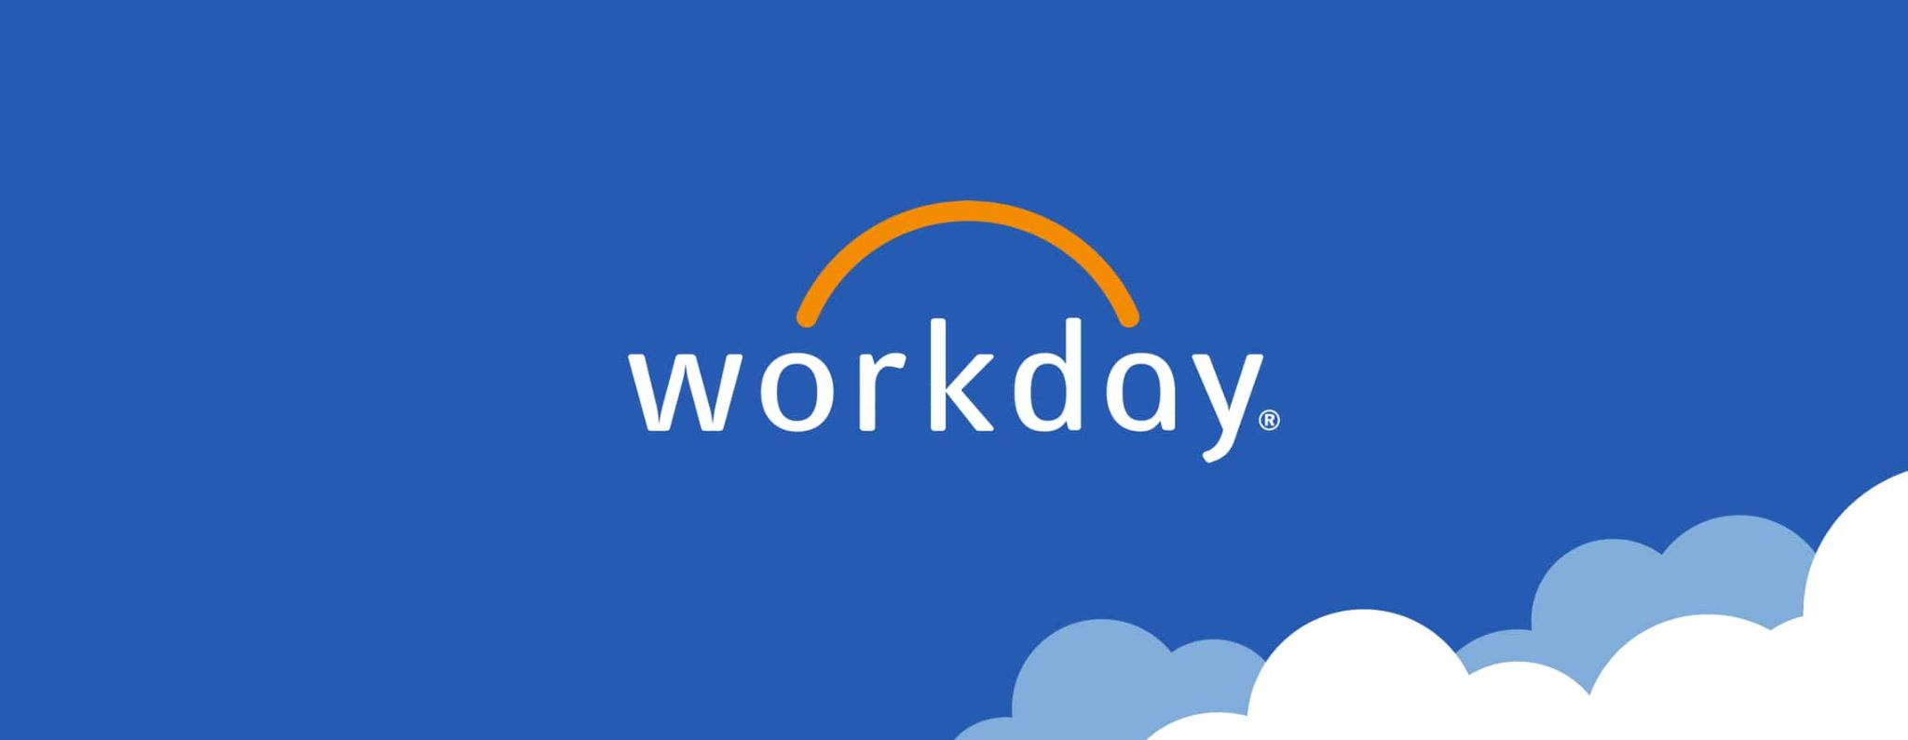

**Workday**

Workday is based on a cloud platform. It is highly flexible which allows users to use in any working environment and having regular updates to the latest version making it run smoothly. This mobile application helps employees and managers to leverage the tool to perform some of the most common actions in Workday without being tied down to a laptop or desktop. Workers may check-in and check-out using their mobile devices and also examine their salary information, make requests for time off or expense reports, check on projects, enrol in benefits in the application. It also provides users/managers with useful information on your team or individual employees from any location and at any time. Examine data on team compensation and performance management. Also, act quickly on duties such as approving spending or scheduling time off at one’s fingertips.

Workday for mobile is simple to deploy and manage, with the same look and feel as Workday for the web and mobile web. And, because it has the same security paradigm as the rest of Workday, this gives users the confidence that information access in Workday is consistent. This method allows for easier security configuration and faster implementation. The app also uses native mobile device technology, such as biometric identification e.g. fingerprints or face recognition, to ensure safe access while providing a consistent user experience for employees. (Workday For Mobile, 2021)

As an employee, the application’s simple interface allows users to review their pay, check in and check out for work, request time off and submit any expenses. Employees will also receive notification alerts for important updates, approvals and time tracking, and they are able to take action immediately right from the application. Not only that, it gives users a platform to check company directory on the go, securely view coworker profiles, offer comments regarding them, and take learning courses.

On the other hand, the manager can take action no matter where they are. Managers can now approve employee requests quickly. They are able to view the team or individual profiles and take quick actions, such as changing jobs suited better for the employee, adjusting remuneration, or providing performance comments. Using interactive reports and dashboards, managers can now stay connected to their business and receive instant insight into what matters.

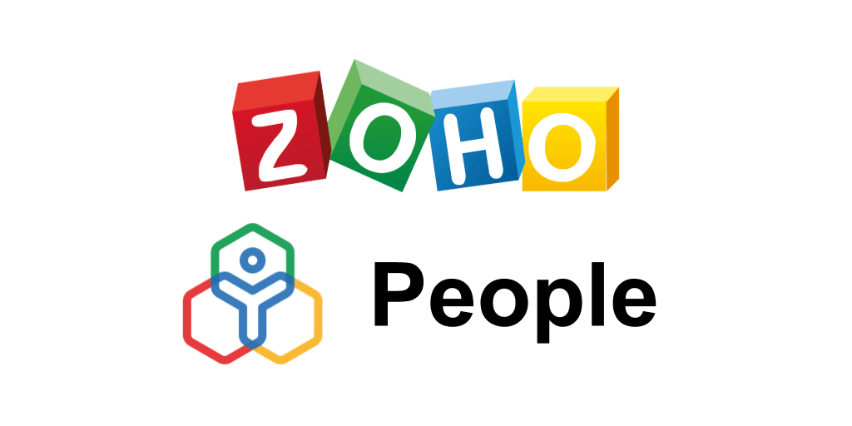

**Zoho People**

The goal of the Zoho People mobile app is to allow employees to easily browse organisational employee directory, perform instant check-in and check-out, and stay connected at all times from their Apple or Android phones.

It is simple to maintain track of employees' daily working hours records, this includes yearly leaves and holidays, which can be easily tracked. This saves a lot of time that would otherwise be spent on filling timesheets in spreadsheets. All of these functionalities are implemented dynamically, making it an effective personnel and business management tool. It aids in centralising all data and making it available to various team members. Not only that, it contains time tracking tools that are important for keeping track of how long a particular project takes. As it runs on a cloud, information being updated is always up to date.

Checking in and out, keeping track of the amount of time spent on a project, approving and rejecting requests, searching colleagues’ details and contacting co-workers via e-mail are the functionalities this app has to offer. (Mobile App | Zoho People, 2021)

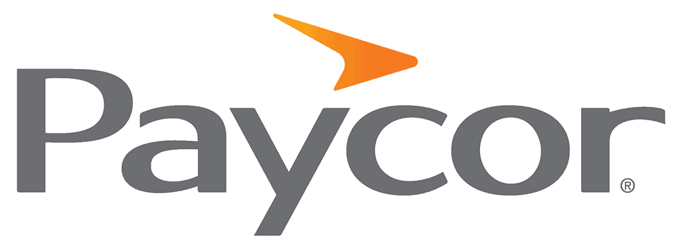

**Paycor Mobile**

Users may access payroll, time and attendance, and HR functions on the move using Paycor Mobile.

Some features may need to be activated by the administrator of the organisation before they show in the app.

For employees, they will be able to carry out different tasks on the go. Completing their timesheet, requesting a leave of absence, requesting a leave of absence, notifications and tasks, and an online learning platform to upgrade their skill set on the go are amongst other useful functionalities. Whereas managers and administrators can accept requests for time off, recognise any deviations regarding employees time card, and approve workflows. (Mobile App - Paycor, 2021)

Paycor's system is easy to use and navigate because of its basic design. Its aim and functionality are simple and straightforward, however this means there are less options for complete customisation. The lack of customisation may be problematic for those who are experienced with payroll and HR systems. Smaller firms looking to simplify, on the other hand, will enjoy how effectively the program's components function together and how easy it is to navigate around and between platforms. Furthermore, because labour management and payroll are linked, a user-friendly report-maker provides various reporting capabilities. Even if users are unfamiliar with the app, the software will guide through every step. Each stage of the app is guided by a visually appealing interface that employs visuals and recognisable easy to follow icons.

**Connecteam**



Connecteam is a mobile app with the aim to allow easier management of the users company and employees. It makes managing teams simpler so that the team can focus more on the task at hand. It is designed to make communication between the members of the team easier and to train and operate their deskless teams from anywhere.

Easy communication between employees and team leaders through multiple methods

* Live chat group conversations
* Announcements
* Directory to all work contacts
* Immediate updates and posts
* Employee feedback surveys
* Suggestion box
* Live polls
* Open door policy allowing employees to address HR easily for better engagement and communication
* Easily access wellness and benefits under one roof, letting employees access policies and wellness plans as well as allowing direct registration from the app to company events

Employee time clock to help keep track of individual team members work hours on the job, projects and with customers with GPS and map display for worldwide view

* GPS location
* Time tracking to know who clocked in when and where in real-time
* Timesheets that automatically calculates over-time, double-time, daily limits with visual flags for payrolls
* Real-time visibility
* Absence and paid time off application notifications to make requests and approvals from the app
* Geofencing capabilities to ensure employees are where they should be
* Auto reminders
* Kiosk station app for a shared work device to log multiple employees work hours
* Manage on-the-gohgi8

Schedule and manage employee shifts, job dispatchment time, and receive live feedback from the team

* Easily create shifts for employees
* Automated notification to accept or reject shifts as manager
* Import shifts from excel file
* Copy previous week schedules and duplicate multiple shifts
* Add customizable notes
* Attach any kind of files with relevant information for the days work
* Attach location address for easy navigation to the work location
* Communications tools for employees to reject, accept, check-in and complete shifts while on the go
* Collaboration between manager and employee on shift planning
* GPS status updates
* Note and photo sharing from the work location for easier management and overseeing

Mobile-first checklist app for deskless employees

* Intuitive drag and drop editor
* Gather info from field team with image-capturing, location stamps,voice recordings, file attachments, signature
* Access to forms and checklists on mobile for on-the-go and deskless team
* Instant compared to traditional paper forms that are sent back and forth
* Real time notifications on mobile for every update or entry
* Track completion rates
* Automatically remind users with follow ups to simplify daily process
* Export and save the data collected

Ease of training employees using the app for company information, policies and training materials

* Deliver training materials through PDF files, documents and web services (Youtube, Dropbox, Google Drive) from one app
* Add quiz to ensure understanding of the content
* Create libraries which are fully searchable and accessible by the deskless teams
* Course completion tracking
* Admin monitoring training progress

**Monday.com Work OS**

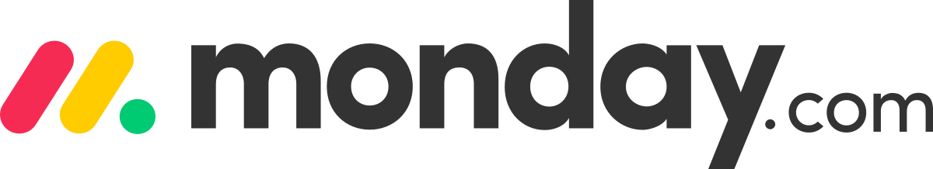

A work management and productivity mobile app to assist the users team with features to promote collaboration between team members and project management. With an interface that helps organize and manage projects, tasks and manage teams.

* Project management
* Progress updates
* Budget approval
* Project status tracking
* Inventory management
* Import excel sheets and present them in intuitive boards
* Flexible ready-made templates to fit any inventory needs
* Automation set up and instant notification for inventory management
* Centralized communication to avoid email chains that can affect productivity for remote workers
* Ready-made platform templates or customize to specific needs of the user
* Task management and checklists
* Timeline
* Date tracking for projects
* Assign person in charge to each item and project
* Live notifications for added comments on project items

# Our Approach: User-Centred Design (UCD)

The goal of the app was to be as user-friendly as possible while keeping the complexity minimal so that it was not too tough for us to create and maintain. Because it is intended for regular usage, the app must be user-friendly. As a result, it necessitates a user interface which is straightforward and easy to use.

The benefits of user-centered design includes increased app safety and effectiveness as a result of user input. As a result, users get a sense of ownership in the product, which motivates them to contribute more to the app.

The drawbacks of user-centered design, on the other hand, are that it takes more time and money. However, in this course, this is not a major issue. It is simple to conduct a survey and get feedback from users while using Typeform and Google Forms. Furthermore, the project is basic enough that it is simple to fix and update in response to user input.

# 

# Early prototypes; strengths and weaknesses

We came up with the storyboard with this scenario in mind. The HR manager of a company is having problems keeping track with the leaves and MCs of the employees. Such issues are clarified on phone or in person, and with many employees it is hard to keep track. DELTA was made to meet the needs of any HR manager and as well as a pleasant experience.

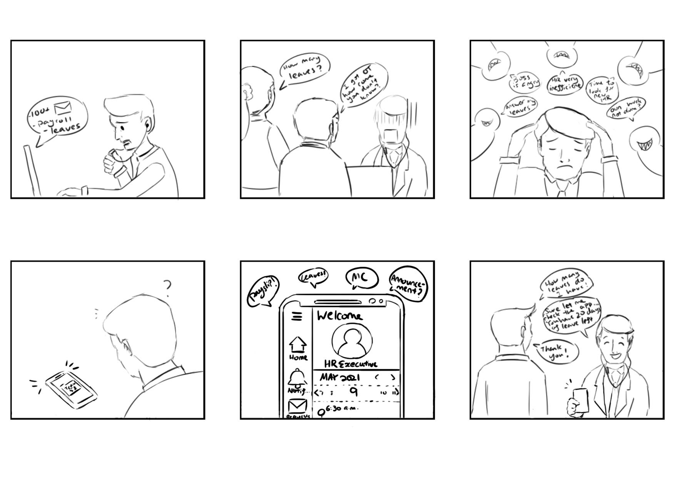

**Strengths of the prototype:**

A meeting amongst the team members was conducted to discuss the first draft for idea 1 for feedback. Feedback was that the overall design seems to be fine, and is well-received and well thought out.

**Weakness of the prototype:**

Adding a dropdown slider to show different positions when accessing the login page. Dropdown slider should show HR Personnel and Employees respectively. An attendance page can be added to both the HR and Employees tab for them to keep track.

Profiles of HR Personnel and Employees can be simple and not too complex. HR has an Employees tab for him or her to search through the list of employees. The format will be similar to a contact list as it is now from web to mobile application and it is easier for accessibility as well for the HR. For the employees and HR tab, instead of the chats tab, a forum announcement box is proposed which makes it simpler for the employees to see.

Heuristics Evaluation

**Visibility of System Status**

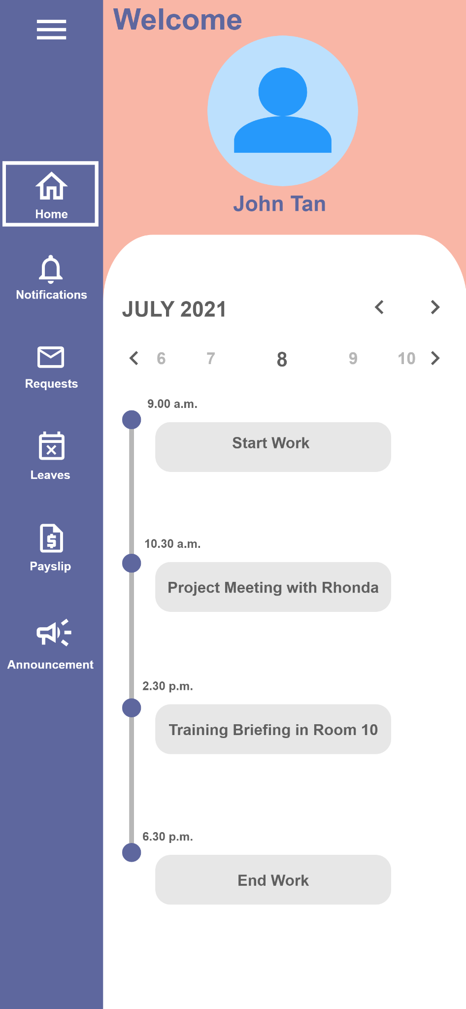

The application has panels on the side to show the user which function it is using, such as settings, and leaves. A rectangle is shown when the user selects a specific function, like notifications or leaves, to indicate that they are using the function. If the user wants to delete any leaves or any note to self, the delete function can be identified and easily deleted. The user can also rearrange the order of the reminders according to most to least importance.

**Match Between System and the Real World**

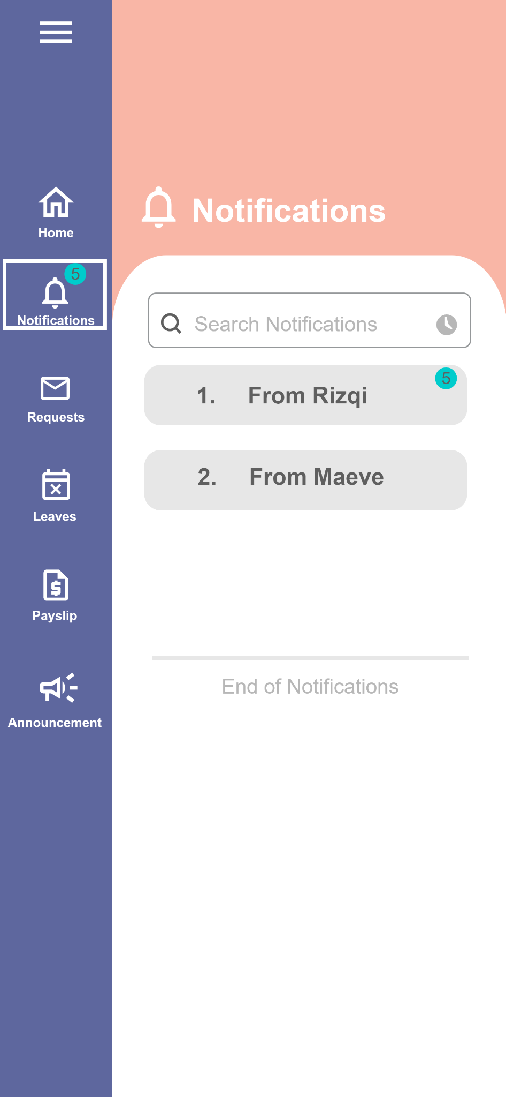

The application has UI elements that are similar to real-world examples. There are quite a few examples in the application, such as the notifications and settings are represented by a bell as bells ring to alert people of the latest news and settings are represented by gears as gears usually symbolise the technical aspects of an application that you need to change, like the colors of the font size for the user.

**User Control and Freedom**

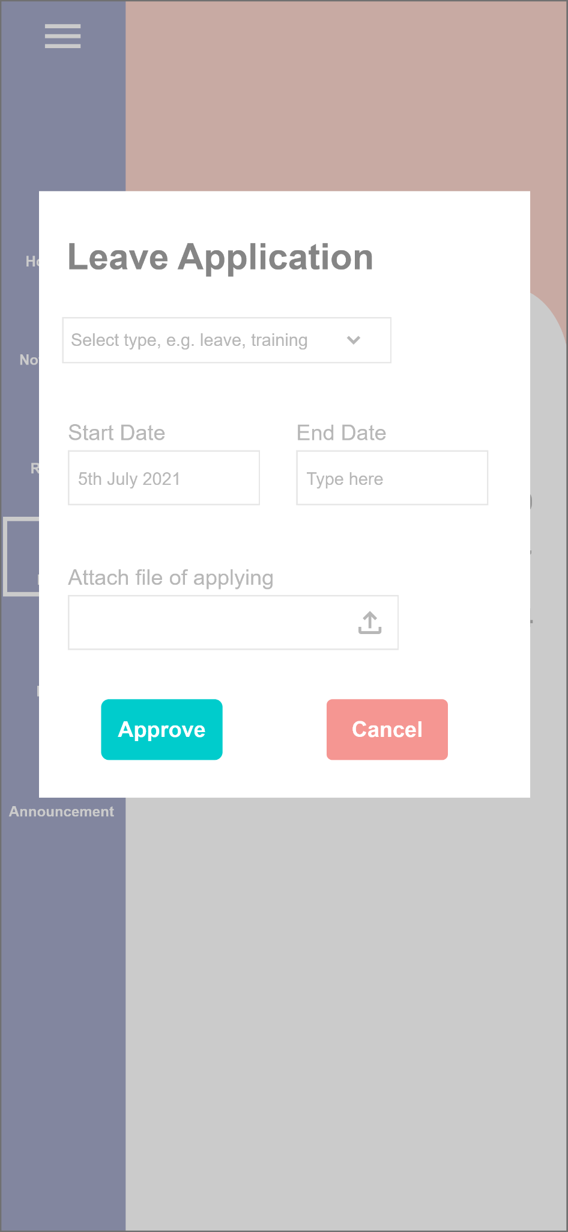

The user is allowed to press back or close a function while it is being used. For example, while the user is applying leaves, after applying it will show the user a box that says the application is successful or unsuccessful. After displaying the message, there is a cancel button to indicate to the user to close it if the user does not want to continue. Additionally, the screen will dim slightly to allow the user to focus on the main message in front of them.

**Consistency and Standards**



The applications have layers of consistency for the user to use. For example, the side panels on the left stay the same as you navigate through the pages. The menu on the top left is consistent as well, similar to most mobile applications. Most fonts used in the application are the same and at most, sometimes bold to exemplify importance. Fonts will not be different throughout the use of the application to ensure consistency though the user can freely change that.

**Error Prevention**

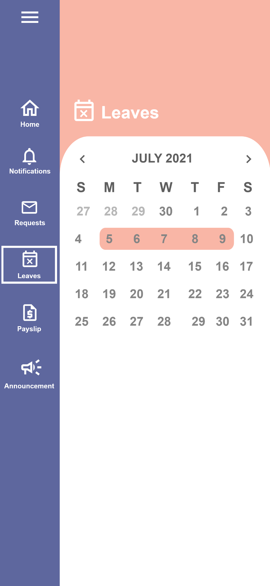

There is error prevention in the application so that the user can have more error-prone experience. For example, when selecting the date to apply for training, the user only has a one-week boundary when selecting the dates. The date chosen can be different and then the boundaries of the date selection is set within that new date. Confirmation page, after finishing leave date selection and training date selection will be shown to allow the user to confirm it.

**Recognition Rather Than Recall**

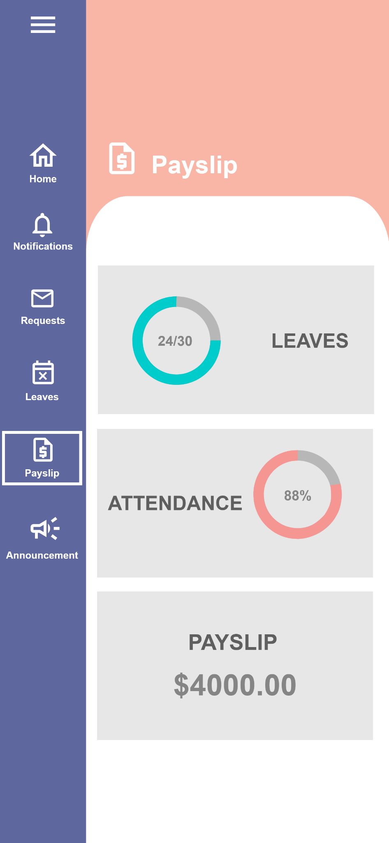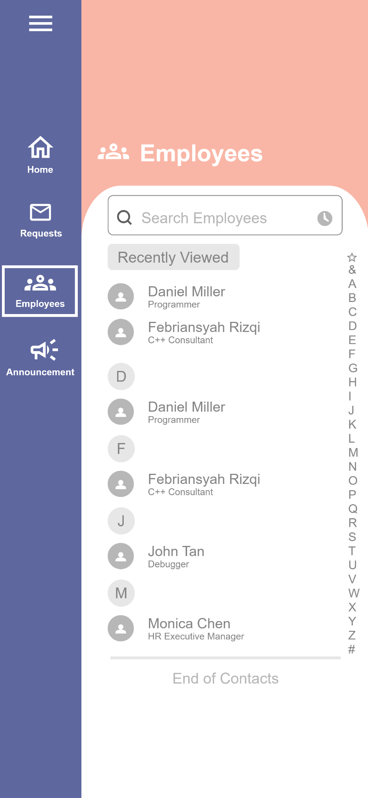

The user should not need to recall how to use the application, and instead it should recognize right away how to use it. The information on the homepage of the screen shows automatically where the user should go for a specific task, without the need to recall how to use the app. It does not have a lot of information that overwhelms the user. For example, the leaves and training page summarises how many leaves the user has. The user does not need to remember the information or even be overwhelmed with information as the information required is just right in front of them with just a click of the function on the side menu. Another example is that the HR version of the application has a search query to search through a specific contact.

**Flexibility and Efficiency of Use Accelerators**

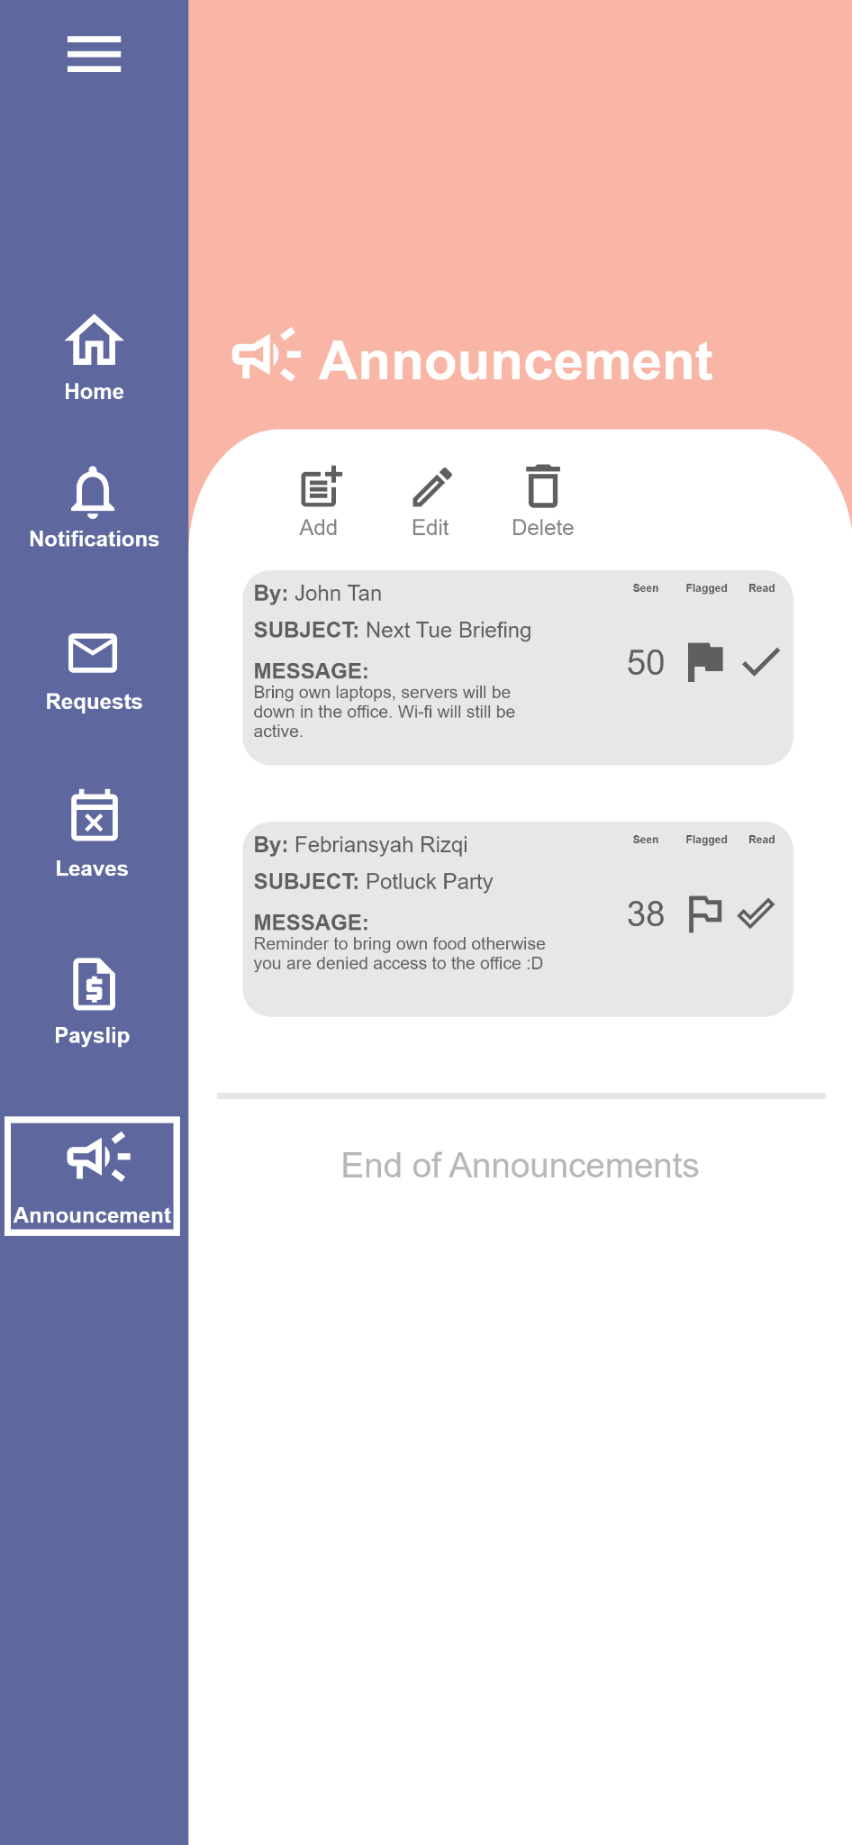

There are some shortcuts for the users of the app. When writing a request to the HR or amending the request, the user is able to highlight a specific section of the paragraph and then, for example, change the words to bold or italic. The copy and paste works too as it is a mobile application. The user can “flag” a specific request or notification of his or her choice.

**Aesthetic and Minimalist Design**



The function logos so far have been minimalistic and simple to work with. Most functions do not have that much “noise” in the app. It’s not too simple to the point where the user does not understand the purpose or navigation of the application. Even then, there are descriptions for each function to help users with it.

**Help Users Recognize, Diagnose, and Recover from Errors**

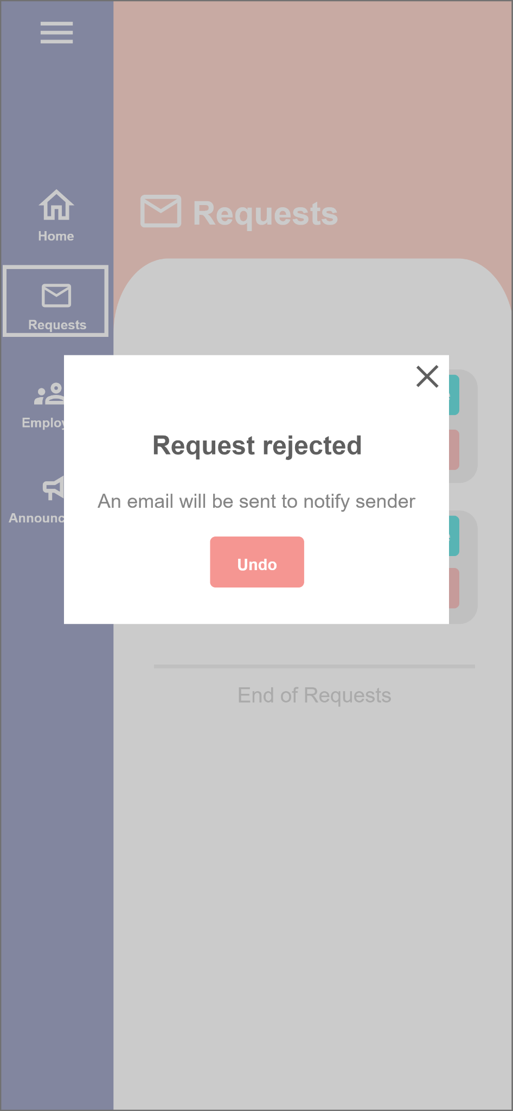

When the HR sends an approval or email to his or her colleagues, the HR will be notified it has been sent but at the same time, still having the undo button in case there are any further amendments required.

**Help and Documentation**

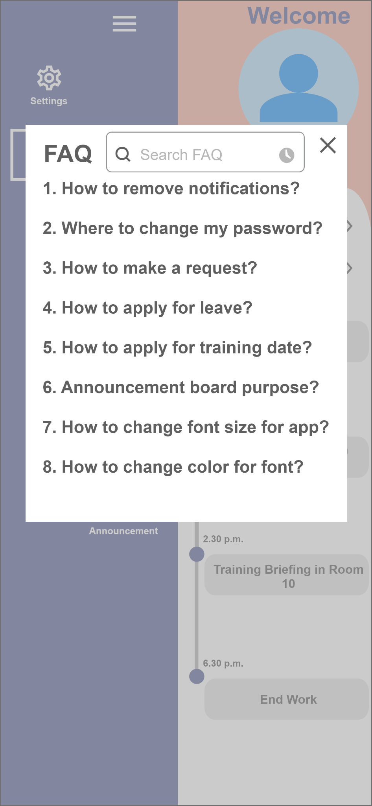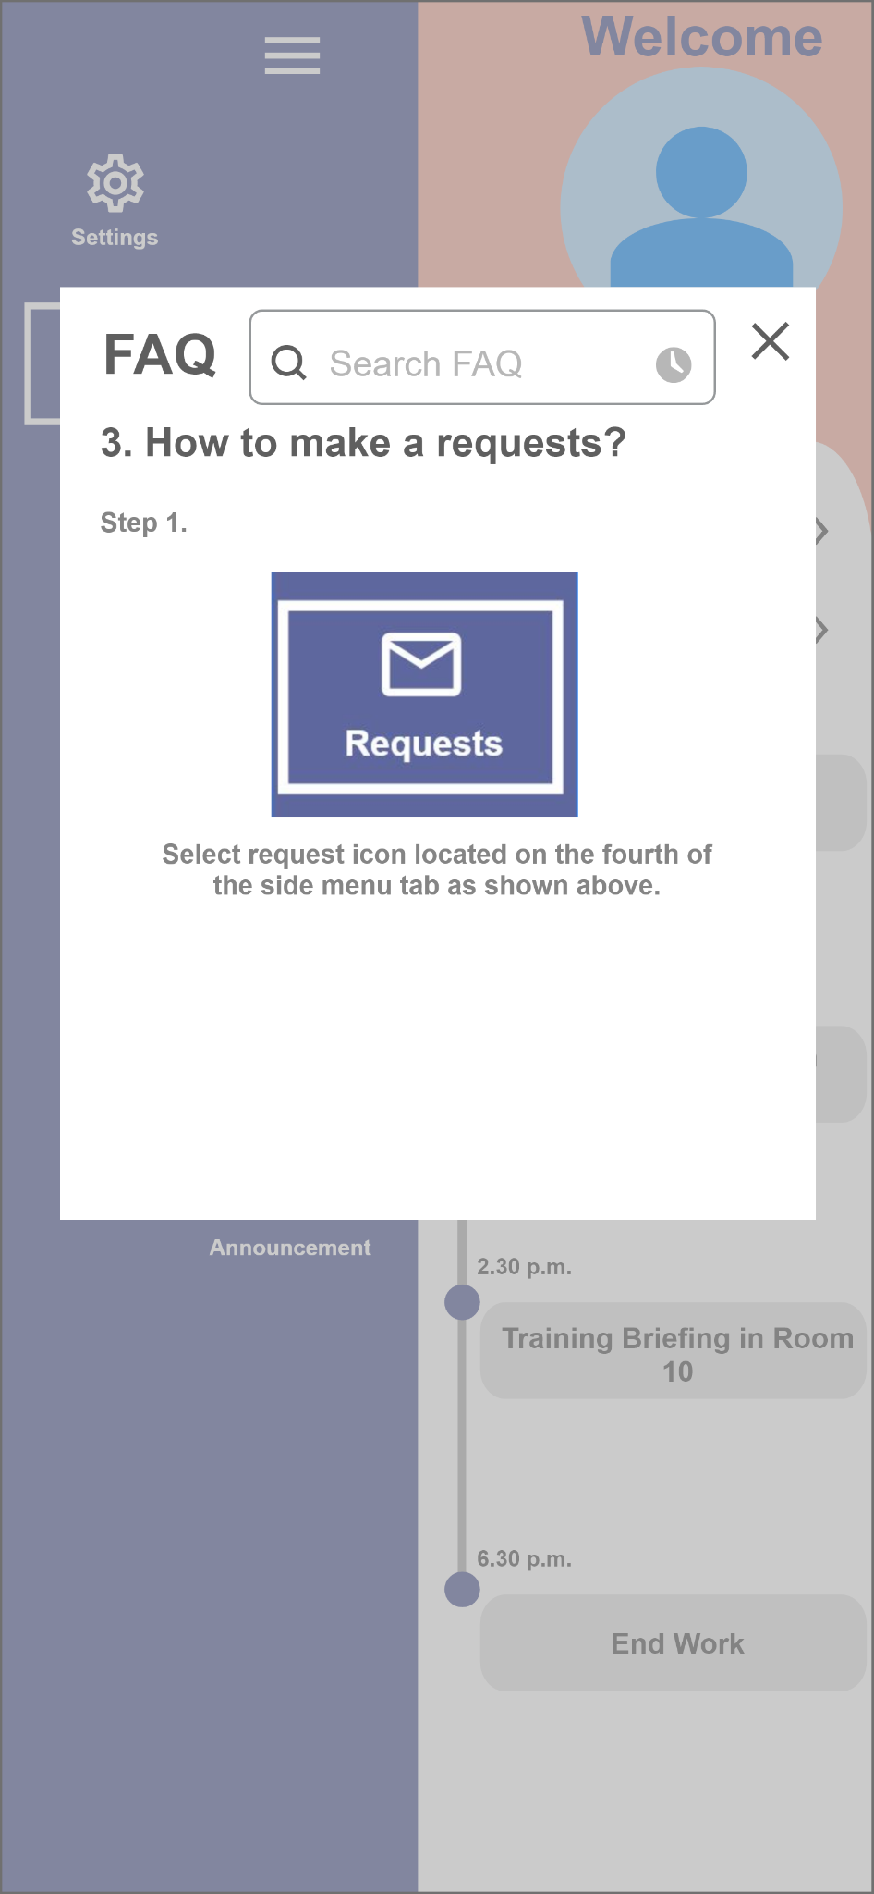

Help for users will be listed in the Frequently Asked Questions (FAQ) found in the menu section. The FAQ will have a search tab and frequently asked. Once searched, the user will have a list of steps provided on how to solve a particular issue. Nevertheless, the contacts of the HR will be provided for any further enquiries for possible problems the user faced.

# Validation of design

Our team has come up with a survey to help us meet the needs of the people. In the survey, we first asked if anyone has used before other EMS and if so, how would they rate the user experience. After that, we introduce our product interface and functions available to receive feedback.

**This is our survey form:**

<https://xjtmgstj2v2.typeform.com/to/JjeEtKJl>

The result is as shown:

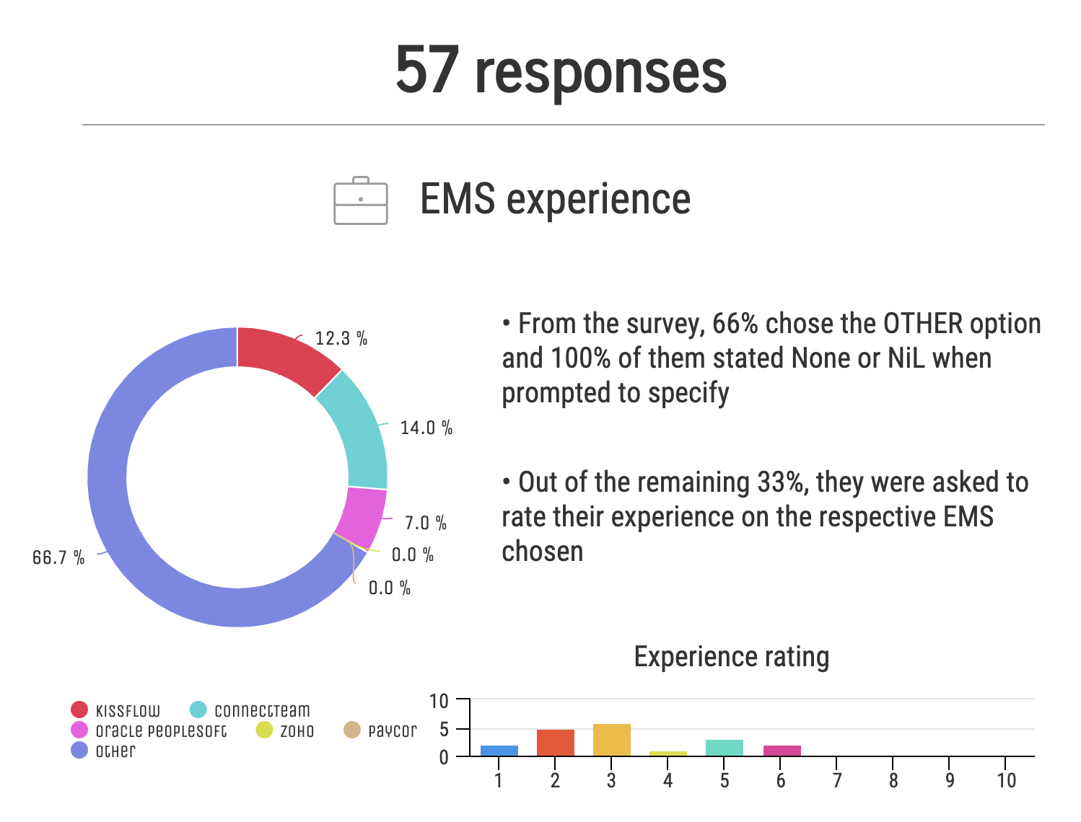

As shown from the statistical data above, it can be assumed that the presence of EMS is not yet widely exposed to many and out of those who have experience with other EMS such as ConnectTeam, Kissflow etc. the overall experience ratings are condensed on the lower end spectrum.

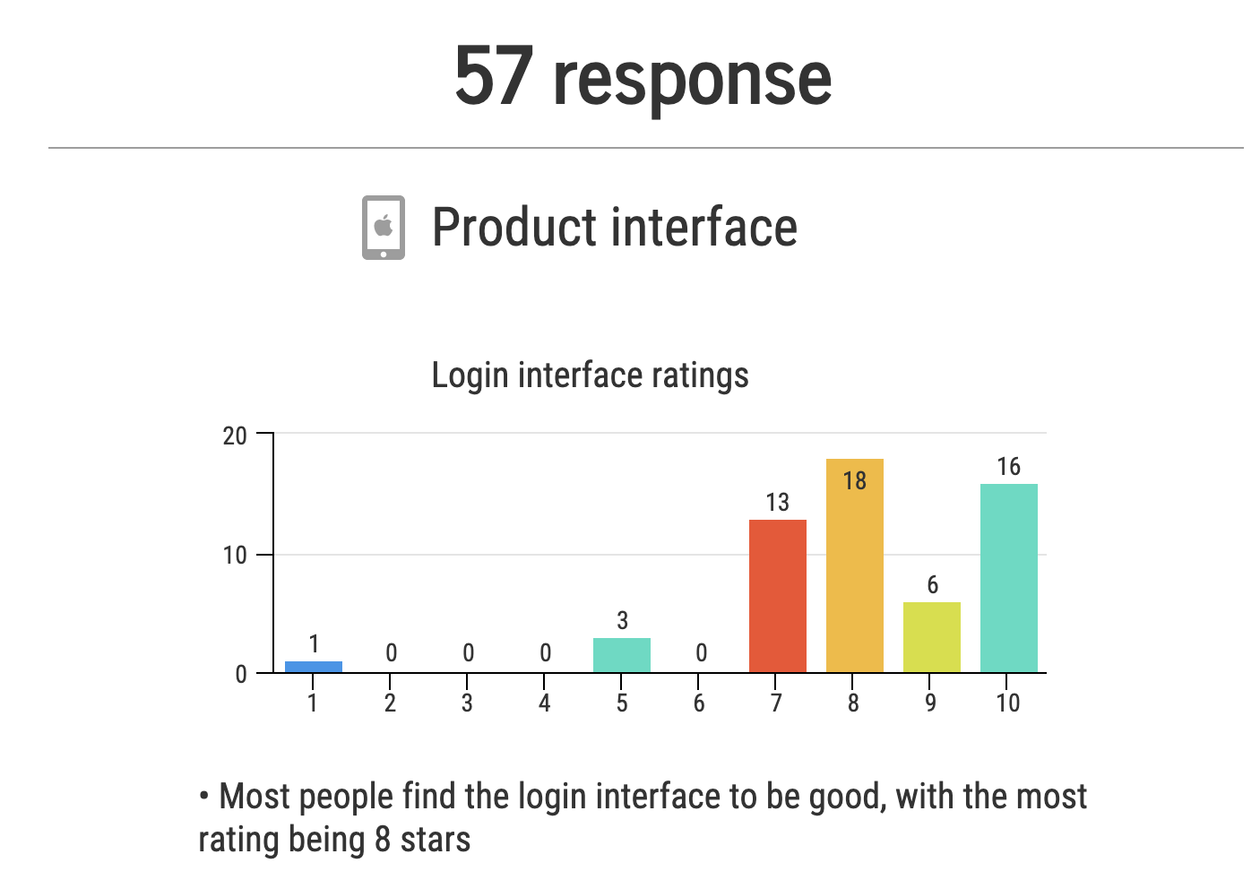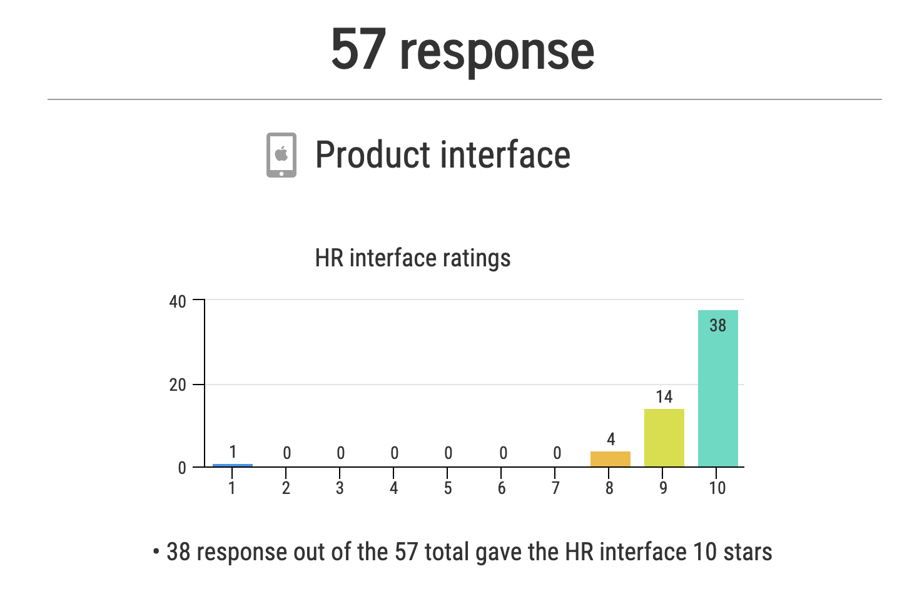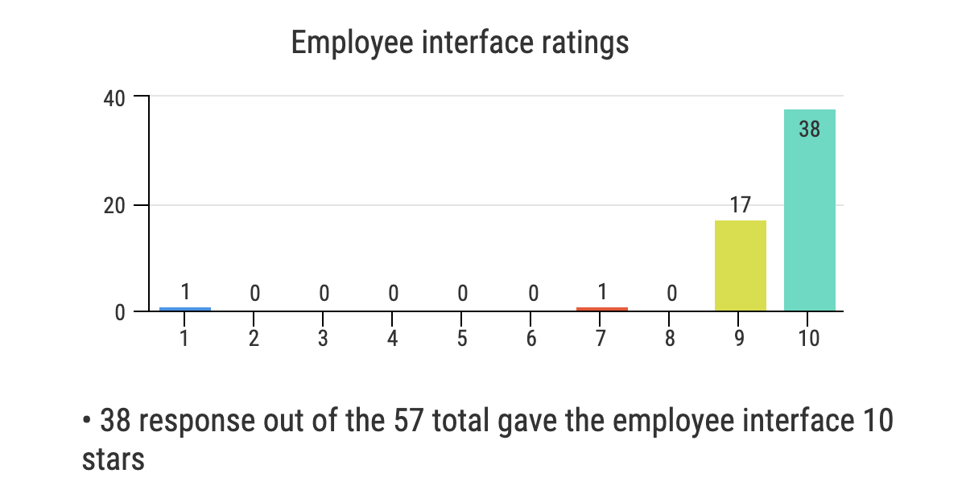

Based on the 3 table charts above, we received very high ratings for all 3 interfaces components from our 57 responses with the exception of 1 to 2 outliers.

We also asked in the survey form if there were any other features users would like to see implemented in DELTA or any design changes to make.

The responses are as shown below.

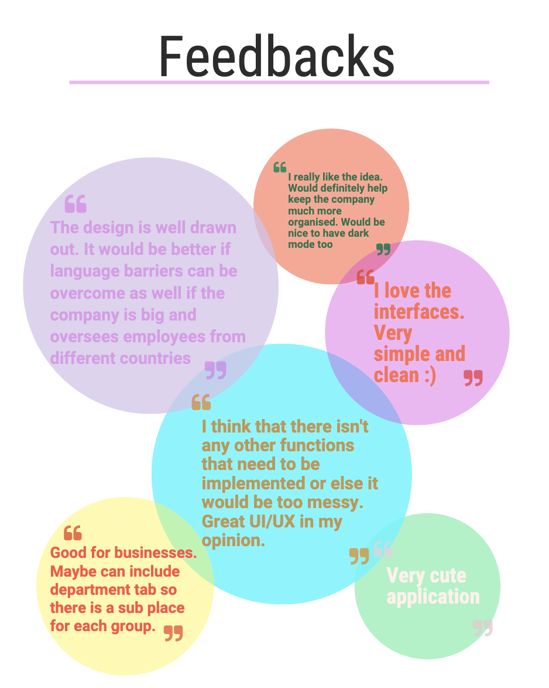

From the survey results above, we can come to a conclusion of the following:

* There is a general satisfaction towards our application. Users like the simple and clean interface, and they feel it will be useful for their businesses.
* Regarding some improvements for our application, they feel that we could slowly implement more features such as more language options, as well as sub-grouping capabilities.

# Critical evaluation of our concept:

Current state

Software is in a conceptual phase. We are in the process of brainstorming ideas we may want to include in our development of the product and currently gathering more information from surveys to get feedback for what features and functions people may want to see implemented.

Visualisation for the app has been done with the app wireframe, allowing us to have a better understanding of how we may want the app to look like and this will make it easier once we get to the development phase as we will have a concrete idea as to what it should look like.

Evaluation:

During the entire process of finalising the framework as well as the prototype, we decided to scrap one idea as we felt that it was unnecessary or over-complicating the functions of our DELTA application.

1. From computer-based software to a mobile application:

Challenges:

A redesign of our prototype, gathering new requirements, analysis of a different group of

competitors.

There were some challenges when changing our idea from a web based app to a mobile based one.

Some of these challenges were shifting our focus from web based app competitors to an analysis of the mobile competitors. Research also had to be done on the different platforms with the shift from computer technical specifications to mobile technical specifications as the hardware on the different platforms would not make the app compatible with each without further research and development. Other challenges that came with changing platforms was our visualization and wireframe. We had laid out what the app may have looked like on the web app and then had to scrap that and redo the wireframe more for mobile focused design.

New opportunities:

The challenges with the constraints of working on one platform did help us to focus on one platform and we were able to finalize ideas better. It opens up the chance for us to code with a mobile based design, function and user base to broaden our horizons.

------------------------------------------------------------ END------------------------------------------------------

**References**

Play.google.com. 2021. *Connecteam - Collaboration App*. [online] Available at: <https://play.google.com/store/apps/details?id=com.connecteamco.Connecteam.app&hl=en_SG&gl=US> [Accessed 11 July 2021].

Connecteam. 2021. *All-in-One Employee App for Mobile Employees - Connecteam*. [online] Available at: <https://connecteam.com/> [Accessed 11 July 2021].

monday.com. 2021. *monday.com | Work Without Limits*. [online] Available at: <https://monday.com/> [Accessed 11 July 2021].

Workday.com. 2021. *Workday For Mobile*. [online] Available at: <https://www.workday.com/content/dam/web/en-us/documents/datasheets/datasheet-workday-mobile-us.pdf> [Accessed 8 July 2021].

Zoho. 2021. *Mobile App | Zoho People*. [online] Available at: <https://www.zoho.com/people/help/adminguide/mobile-app.html> [Accessed 9 July 2021].

Paycor. 2021. *Mobile App - Paycor*. [online] Available at: <https://www.paycor.com/hcm-software/payroll-software/mobile-app/> [Accessed 5 July 2021].